TEMPLATE FOR PRACTICE WITH PARENTS
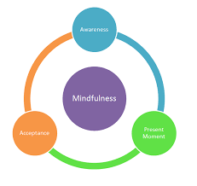
TITLE: Mindfulness in Conflicts
AREA (OBJECTIVES):
- Management of conflicts.
- Emotional regulation.
- Favors self-control.
THEORETICAL BACKGROUD (if needed):
Mindfulness in the resolution of conflicts.

DESCRIPTION:
Mindfulness tips for reducing reactivity. We can use mindful practices to create space between an outburst of anger or another strong emotion so that we may have more possibility to choose in a conscious way. In some situations, this could be just walking away or taking a pause, or a deep breath before we speak. As we learn to practice these skills ourselves, we can later on teach our kids on how to respond mindfully.
The steps that will help us become mindful in a conflict situation will be:
- Always pause — When a conflict arises, take a pause and a deep breath. Take a moment to breathe slowly and notice the air coming into and going out of your lungs and belly. Focusing on your breath and body so that you ground yourself in the present moment. Come out of the mind as much as you can.
- Allow yourself to feel what you’re feeling — Pay attention to your thoughts and emotions, knowing that you are not them. Is your mind racing with angry thoughts? Do you feel hurt or embarrassed? Just become aware of thoughts and emotions that arise in you and accept them. They will settle if you don’t react to them, and just let them be and embrace them with full acceptance.
- Do a brief body scan— Notice the physical sensations that arise with your thoughts and emotions. Are you clenching your jaw? Are you tightening your fists, ready to hit something? Are your leg muscles twitching, urging you to flee? Notice any muscle tension from your toes to the top of your head.
- Settle into your breath — As you breathe, you will notice a pause at the end of each out breath before you breathe in again. During this pause, relax, and soften your muscles. Keep doing this for a few minutes, relaxing deeper and deeper into each pause.

- Acknowledge that you have space to choose — Accept that you are upset and don’t try to change it. You could even say aloud, “I am upset.” Choose to be patient with yourself. If, however, your emotions feel too strong to investigate, acknowledge your difficulty and move away from the troubling situation. You can choose to return to the issue when you feel calmer, and choose a quiet space to get in contact with how you are feeling and the thoughts that are appearing on you.
- Challenge your assumptions — Be open-minded to the views of others involved in the conflict. Don’t assume you know where people’s ideas come from or how other people are feeling. Challenge yourself to ask open-ended questions so that you can truly understand their perspective, and widen your view of life. Remember you are not your beliefs, and that is better to be happy then to be right.
- Avoid negative speech — Name-calling is never helpful. Instead, explain your point of view clearly and acknowledge the viewpoints of others.
- Suggest a resolution — Stick to the point of the conflict and suggest one or more ways to resolve it. Calmly discuss the pros and cons of each suggestion.
- Move forward — Agree to try a resolution without resentment. And when you move forward with a suggestion, give it your full effort.
- Forgive —Holding onto anger and resentment only hurts us and burdens relationships. Forgive yourself and others for being different and having an argument, and accept the idea that by learning to resolve conflict, we grow as people.
By practicing these 10 steps regularly, you can build a sense of confidence, well-being, and acceptance of challenging situations. These skills will serve you when you feel angry or divided as well as model resilient and positive examples of conflict resolution for our kids.
Write the steps in a paper and follow them whenever you find yourself in a conflict situation. Respect what you are feeling in each moment, and you can ask yourself “what do you need to learn from this situation?” to help you dissolve the conflict.
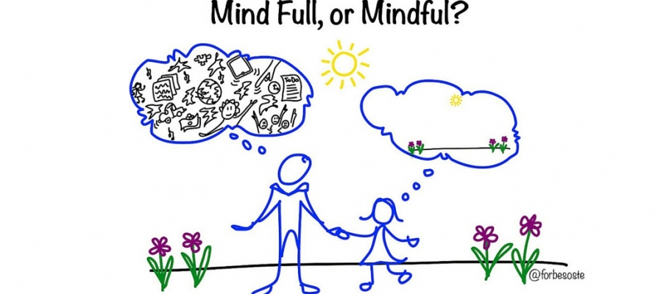

EVALUATION OF THE PRACTICE:
After putting it into practice we can see changes in the management of the conflict. Specially in the changes from being reactive, to becoming active, with more possibilities to choose.
COMMENTS FOR IMPLEMENTATION (if possible):
OTHER USEFUL RESOURCES (e.x links where you can find more information on the given topic):
Fleet Maull’s Prison Mindfulness Institute’s Path of Freedom course
Gina Biegel’s Stressed Teens program.

- Please add additional materials if needed, such as: schemes, templates, pictures or sth else if your practice requires it.
- Please add illustration if you have it. It can help to understand your idea by readers
- In case of practice with parents, please read carefully all of our suggestions on page 2.
- There can be situation that provided template won’t fit to your practice. Give us a sign on this. We can make some changes together.

