INTELLECTUAL OUTPUT NO O1

PEDAGOGICAL KIT/MODEL

PART 2 – PRACTICAL TOOLKIT



Table of Contents

HOW TO WORK WITH PUPILS 4

MY FAVOURITE FLOWER 7

BALLOONS OF ANGER 9

MINDFULNESS 11

SECRET OF AUNT CLARA 14

SIGN OF STRESS 17

А COUPON FOR ANY OCCASION 20

WORD TENNIS 21

OUT OF CHAOS-POLIS – The rules for well-being together 22

DESERT ISLAND 31

THERAPEUTIC FAIRY TALE 33

FAIRY TALE ABOUT FEELINGS 36

THE MIME GAME 38

CLASS CALENDAR 40

COMMON HEADS 42

I CHOOSE! 43

SNAKES AND LADDERS FOR KNOWING EACH OTHER 45

THERMOMETER OF FEELINGS 48

WHERE IS THE STRESS? 52

THE TOWER 55

WORDS FOR FEELINGS 57

GOOD MORNING, CAPTAIN! 60

QUIZ MARKET 61

BODY SCAN 63

CONSCIOUS EATING 66

COUNTING BREATHS 68

GROUP CLASS 70

CONFLICTS, NO! 72

SONG WITH DIFFERENT RYTHMS 74

HOW TO WORK WITH PARENTS 75

FECE 77

A BOOK A WAY TO FIGHT THE BOREDOM 79

GOT TALENT 80

HEALTHY BREAKFAST 81

LITTLE TOOLKIT TO INVOLVE PARENTS IN SCHOOL LIFE 82

PARENTS TEACHING PROSOCIAL SKILLS 88

SCHOOL FEAST 95

LET ME TELL YOU ABOUT MY JOB…/VOCATIONAL CONSULTING 96

BEGINNING ANEW 99

MINDFULNESS IN CONFLICTS 102

OFF-LINE FACEBOOK 105

PARENTS’ MEMORY GAME 106

LIKE SOCRATES: EDUCATING TO CRITICAL THINKING 107

ANIMALS’ EMOTIONS GAME 109

PARENTS’ SCHOOL / SCHOOL FOR PARENTS 112

ROUND TABLE WITH ... PARENTS AND GUARDIANS ON POSITIVE PARENTING 113

BIBLIOGRAPHY 121

## HOW TO WORK WITH PUPILS

|  |  |  |  |  |  |  |  |  |  |  |  |  |  |  |  |  |  |  |
| --- | --- | --- | --- | --- | --- | --- | --- | --- | --- | --- | --- | --- | --- | --- | --- | --- | --- | --- |
|  | Activity | *Planning skills* | *Motivation to act (e.x. learning)* | *Organisational skills* | *Ability to relax and rest* | *Coping with stress* | *Effective learning* | *Creativity and creative thinking* | *Independent and critical thinking* | *Changing habits of thinking, changing beliefs* | *Emotional intelligence, empathy* | *Entrepreneurship* | *Assertiveness* | *Conflicts management* | *Interpersonal communication* | *Teamwork* | *Personal culture* | *Age group* |
| 1 | My favorite flower |  |  |  | X | X |  |  |  |  | X |  |  |  |  |  |  | 6-7 |
| 2 | Balloons of anger |  |  |  | X | X |  |  |  |  | X |  |  |  |  |  |  | 6-7 |
| 3 | Mindfulness |  |  |  |  | X |  |  |  | X | X |  |  |  | X |  | X | 6-7 |
| 4 | Secret of Aunt Clara |  |  |  |  |  |  |  |  |  |  |  |  |  | X |  | X | 6-7 |
| 5 | Sign of stress |  |  |  |  | X |  |  |  |  |  |  |  |  |  |  |  | 6-7 |
| 6 | А coupon for any occasion | X | X |  | X | X | X |  |  | X | X |  |  |  | X |  | X | 6-7 |
| 7 | Word tennis |  |  |  |  |  | X |  |  |  |  |  |  |  |  |  |  | 6-7 |
| 8 | Out of chaos-polis |  |  |  |  |  |  |  |  |  |  |  |  |  | X |  |  | 6-7 |
| 9 | Desert island |  |  |  |  |  |  | X |  |  |  | X |  |  | X | X |  | 8-9 |
| 10 | Therapeutic fairy tale |  |  |  |  |  |  |  |  | X | X |  |  | X | X | X | X | 8-9 |
| 11 | Fairy tale about feelings |  |  |  |  |  |  |  |  |  | X |  |  |  |  |  |  | 8-9 |
| 12 | The Mime Game |  |  |  |  |  |  |  |  |  |  |  |  |  | X |  |  | 8-9 |
| 13 | Class calendar | X | X |  | X | X | X | X |  | X | X |  | X |  | X | X | X | 8-9 |
| 14 | Common heads |  |  |  |  |  |  |  |  |  |  |  |  |  | X |  |  | 8-9 |
| 15 | I choose! |  |  |  |  |  |  |  | X |  |  |  |  |  |  |  |  | 8-9 |
| 16 | Snakes and ladders for knowing each other |  |  |  |  |  |  |  |  |  |  |  |  |  | X |  |  | 8-9  10-11 |
| 17 | Thermometer of feelings |  |  |  |  |  |  |  |  | X | X |  |  | X |  |  |  | 10-11 |
| 18 | Where is the stress? |  |  |  |  | X |  |  |  |  | X |  |  |  |  |  |  | 10-11 |
| 19 | The tower | X | X | X |  |  |  | X |  |  |  | X |  |  | X | X |  | 10-11 |
| 20 | Words for feelings |  |  |  |  | X |  |  |  |  | X |  |  |  |  |  |  | 10-11 |
| 21 | Good morning, Captain! | X | X | X | X | X |  | X |  | X | X |  | X |  | X | X |  | 10-11 |
| 22 | Quiz market |  |  |  |  |  | X |  |  |  |  |  | X |  |  | X |  | 10-11 |
| 23 | Body scan |  | X |  | X | X |  | X |  |  | X |  |  |  |  |  |  | All ages |
| 24 | Conscious Eating |  | X |  | X | X |  |  |  |  | X |  | X | X |  | X |  | All ages |
| 25 | Counting breaths |  |  |  | X | X |  |  |  |  | X |  |  |  |  |  |  | All ages |
| 26 | Group Class |  |  |  |  |  |  |  |  |  | X |  |  |  |  | X | X | All ages |
| 27 | Conflicts, no! |  |  |  |  |  |  | X | X |  |  |  | X | X |  | X |  | All ages |
| 28 | Song with different rhythms |  |  |  |  |  |  |  |  |  | X |  |  |  |  | X |  | All ages |

### MY FAVOURITE FLOWER

**OBJECTIVES:**  **SUGGESTED AGE GROUP**: pupils age 6-7 years old

Thanks to the implementation of the exercise, pupils:

* learn the ways and techniques of relaxation;
* develop the skills of relaxation and rest;
* develop self-awareness of their own emotions and feelings (emotional intelligence);
* acquire a new ability to cope with stress.

**WHEN TO IMPLEMENT THE PRACTICE DURING DIDACTIC PROCESS**:

Exercise can be carried out according to the group's needs, for example at the beginning or end of school day (school activities), but also in a situation requiring silence and reduction of stress levels among pupils.

**METHODOLOGY**:

Expressive and practical methods;

Techniques: Interactive games and activities.

**FORM OF WORK**:

Individual work.

**NEEDED MATERIALS**:

* Rubber mat / mattress / carpet / blanket;
* Possibly a disc with soft music and a CD player;
* Eye bands (if needed).

**DESCRIPTION OF ACTIVITY**:

1. Participants are placed on the floor in a comfortable position (so as not to disturb each other).
2. We ask pupils to close their eyes. (If some pupils need teacher can give them eye bands).
3. The teacher gives the instruction: "Imagine that the sun is shining, it is a warm summer day, we are walking the road, passing fields, meadows and gardens. We see there our favourite flower. We look closely at it: the stem, leaves, petals and their colour, the interior of the bud, post. Now put it aside and paint in your fantasy your favourite flower (30 to 60 seconds). It is certainly ready. Say good-bye to your flower and very slowly open your eyes."
4. The teacher asks the pupils: "We get up, curl up, fall to the right side and rise to the position on our knees. Slowly, we get up on our feet, opening from this position like a flower, which releases shoots from the ground, and then develops its petals. "
5. Completing the task - we ask that children to stand in a circle and summarize the task.

**HOW TO EVALUATE THE ACTIVITY:**

Children tell in a group:

* what their favourite flower looks like;
* what is its name;
* where they found it;
* what was it in touch;
* how it smelled.

**COMMENTS FOR IMPLEMENTATION** (if possible)

1. We pay special attention to the children's position (position of relaxation).
2. You always have to remember that such trips to the land of fantasy should last from five to ten minutes. It depends on the age of the participants, on their ability to concentrate and on the general mood.
3. After the exercise, the teacher can tell pupils about visualization as one of the ways to calm down, deal with emotions, deal with stress.

BALLOONS OF ANGER**[1]**

**OBJECTIVES:** **SUGGESTED AGE GROUP:** pupils age 6-7 years old

Thanks to the implementation of the exercise, pupils:

* understand what anger is and will know how to express it properly;
* will be able to identify anger signals felt in the body.

**WHEN TO IMPLEMENT THE PRACTICE DURING DIDACTIC PROCESS:**

Working with the emotion of anger is a very important element of caring for the mental well-being of older and younger children. It is worth to teach children how to recognize anger signals and tell them how to deal with this emotion. The exercise can be carried out during the didactic process while discussing the topic of emotions, or a few days after the situation, which, for example, caused anger among pupils etc.

**METHODOLOGY:**

Expressive and practical methods;

Techniques: Interactive games and activities.

**FORM OF WORK:**

Individual and group work.

**NEEDED MATERIALS**:

Balloons - the same number of balloons as children (plus a few extra balloons), a string.

**DESCRIPTION OF ACTIVITY**:

**Part I**

We ask children to inflate the balloons and help them to tie the balloons. Then we explain that the balloon is the body and the air inside is the anger that accumulates in the body.

We talk with children about this:

* Can the air get out of the balloon?
* What will happen when anger gets stuck inside (in the body)? / How does our body behave when anger accumulates in it?
* What will happen if we break the balloon?

Then we compare the balloon to the person and talk about what can be compared with the puncture of a balloon (puncturing a balloon = hitting someone, shouting at another person, destroying something, etc.)

**Part II**

We ask the children to inflate the balloons again. This time the balloon is not bound. The child is supposed to slowly release the air from the balloon.

We talk with children about this:

* Is the balloon smaller?
* Did the balloon explode?
* Is the balloon and everyone around you safe when you release "anger"?
* Is it a safer way to get rid of anger?

In the further part of the activity, we help children identify adequate ways of dealing with anger. In older children, it can be, for example, deep breaths, physical activity or "withdrawal" to cool down from emotions. For younger children, it may be helpful to draw anger or tear the newspapers from the "box of anger". There are really many useful ways to deal with anger, it is important that the child as much as possible can identify those that he/she considers particularly useful. The aim of this part of the activity is to show children how to safely reduce the intensity of perceived anger, and thus effectively deal with this difficult emotion.

**HOW TO EVALUATE THE ACTIVITY**:

Pupils answer questions:

* What did you learn new?
* How will you deal with anger now?

**COMMENTS FOR IMPLEMENTATION** (if possible)

The activity is especially useful when working with aggressive children who have a problem with controlling anger or with children suppressing anger.

MINDFULNESS**[2]**

**OBJECTIVES:** **SUGGESTED AGE GROUP:** pupils age 6-7 years old

Thanks to the implementation of the exercise, pupils:

* get to know the tools by which they will be more aware of themselves and the world;
* develop a greater awareness of internal and external experiences;
* will recognize their thoughts as "just thoughts";
* will understand how emotions manifest in the body;
* will have more control over their internal impulses.

**WHEN TO IMPLEMENT THE PRACTICE DURING DIDACTIC PROCESS:**

The exercise can be carried out as cycles, a series of classes, for example during an educational hour or to start the day at school.

**METHODOLOGY:**

Expressive and practical methods;

Techniques: Interactive games and activities.

**FORM OF WORK:**

Individual or group.

**NEEDED MATERIALS**:

No extra materials are needed.

**DESCRIPTION OF ACTIVITY**:

1. ***Sounds***

It's a bit more extensive exercise with gong (if we do not have a gong, we can use the guitar's strings or the most resonant kitchen utensils and spoons).

We hit the gong. Children carefully listen to the sound vibrations. They raise their hands when they hear nothing. They stay in silence for another minute and listen carefully to all other sounds that appear. At the end, they each of them tells story of each sound they have noticed during this minute.

1. ***Breathing with a small friend***

Children lie on the floor and place a mascot on their belly. They breathe in silence for a minute and notice their little friend moving up and down. They also try to notice all other impressions. They imagine that thoughts that appear in their heads change into soap bubbles and fly away ...

1. ***Stretching / relaxing***

Children lying on the floor with their eyes closed try to stretch every muscle in the body as much as they can. Toes and feet, legs, belly. They can clench their fists and raise their hands to their heads. They remain in this compressed position for a few seconds and then fully relax. **It's a great exercise for relaxing the body and mind. It is also an easy way to present to children what it means to be "here and now"**.

1. ***Smell and taste***

Find something that smells strong, like fresh orange zest, cinnamon or vanilla stick. Ask the children to close their eyes and inhale the smell, focusing their full attention on it. **Smell can be a very effective tool in reducing anxiety**.

A similar exercise can be done with the sense of taste. Let's try to do with the children a classic mindfulness exercise: children with closed eyes taste the raisin, trying to eat it as long as possible, paying attention to all shades of taste.

We can also use a chocolate bar;)

1. ***The art of touch***

Children with closed eyes touch various objects, for example balls, feathers, mascots, stones ... Then they describe what the object is in touch.

This exercise, like the previous ones, allows children to practice distinguishing sensory impressions. By focusing on them, they learn to stay in the present.

1. ***Heartbeat***

Children jump or dance for a minute. Then they sit down and put their hands on the heart. With closed eyes, they try to feel heartbeats, breath and other sensations that appear in the body.

1. ***Heart to heart***

**We talk about feelings.**

What feelings do children feel? How do they know that they feel these emotions? Where do they feel them in the body? Which feelings do they like the most?

Later, we can ask what they do when they do not feel those feelings they like the most.

We can remind them that when they feel sadness they can practice turning their thoughts into soap bubbles.

That they can do the stretching and relaxing of the body to calm down.

That they can listen to the beating of their heart or focus on the breath to relax ...

**COMMENTS FOR IMPLEMENTATION** (if possible)

**Mindfulness** is a state of mind, achieved by focusing attention on the present moment, with a simultaneous gentle acceptance of emotions, thoughts and sensory impressions. It is used as a therapeutic technique.

Adults practice mindfulness among others through meditation and various forms of conscious action in everyday life.

Meditation for children must meet three basic conditions: be short, engaging and fun. And so are the mindfulness activities for children.

### SECRET OF AUNT CLARA

**OBJECTIVES:** **SUGGESTED AGE GROUP:** pupils age 6-7 years old

Thanks to the implementation of the exercise, pupils:

* get acquainted with polite phrases;
* will find out why these phrases are important in life and in what situations they should be used.

**WHEN TO IMPLEMENT THE PRACTICE DURING DIDACTIC PROCESS:**

Exercise can be carried out during the educational hour.

**METHODOLOGY:**

Expressive and practical methods;

Techniques: Interactive games and activities.

**FORM OF WORK:**

Individual work.

Group discussion.

**NEEDED MATERIALS**:

The content of the story *"Secret of Aunt Clara"* for the teacher.

**DESCRIPTION OF ACTIVITY**:

The teacher tells pupils that now he/she would like to invite them to listen to a story asks them to sit comfortably. Then he/she tells a fairy tale with a calm voice.

*„Secret of Aunt Clara” – storytelling (land of politeness)[3]*

*Quite recently, on Saturday, Agatha celebrated her seventh birthday. From the morning, as soon as she opened her eyes, she waited for the surprises that the day would bring.  
"Agatha, my princess," my mother called from the kitchen. - Get up quickly and come for breakfast, I've prepared everything you like.*

*Agatha's favourite mug was standing on the kitchen table, the one with red elephants, with steaming cocoa with whipped cream, next to it were the soft and crispy crunchy buns.*

*- Yummmy! Agatha began to eat quickly.*

*- And this is not the end - mom smiled encouraging - For dessert will be ice cream, lemon, as you like.*

*- Great! - Agatha praised her, scraping the leftovers of the egg yolk - Give them to me quickly, because the movie on TV is about to begin.*

*When she saw the movie, she drew a little with new crayons, and to be honest, she was bored a little bit of waiting for grandma and grandpa invited for a birthday dinner.*

*- Ding-dong! - the bell announced the arrival of grandparents.*

*- I will open it, I will open it! Agatha jumped to the door because she knew that grandma and grandpa would not come empty-handed in such an important day for her.*

*- How do you feel, my granddaughter, my brave seven-year-old? - grandmother smiled from the doorway, hiding behind her a quite large package.*

*Agatha was bouncing with impatience.*

*"Oh, Kate” grandfather Teddy scolded grandmother. - Quickly give Agatha the gift, because you see that she cannot wait.*

*He took a package from grandmother's hands and gave it to Agatha. - Grow big, my little Fish!  
Agatha broke the paper very quickly. - Oh, how nice! Blocks! Lego! Cool! A new set, like in a TV commercial! I've always dreamed about that!*

*She immediately ran to the room to build a new cottage with a bower for the dolls.*

*And for the dinner, there were only surprises too. Fries, chicken in a crispy coconut coating and a great carrot with peas. Lick your fingers! Agatha ate the whole portion and reached for her favourite jelly cheesecake.*

*- What a bad luck! She screamed when she accidentally hit a cup with her grandma's coffee. Brown boiling water splashed instantly into a large stain on the tablecloth and a bit smaller on grandmother's new suit. Dad jumped to help immediately. Agatha, using the confusion, rushed to her room and lied on the bed. She covered her head with a pillow. She felt uncomfortable. She did not want it to happen.*

*- Hello Agatha - a stranger, but a nice voice made Agatha look up.*

*- Where did this woman come from? - the girl was surprised.*

*- You're surprised, that's for sure, but I've known you for a long time. I'm your aunt Clara. I live quite far away, that's why you do not know me.*

*A nice, smiling lady, a little older than her mother, leaned over Agatha.  
- I live in the Land of Politeness, it's a long way from here. Today, however, on the day of your birthday, I wanted to take you on a trip there..*

*She nodded and it was not known from where the strange vehicle appeared in the room, just like a large plastic bowl shimmering with celadon light.*

*- Get in - full of encouragement, warm voice of aunt Clara caused that Agatha did not think for long. The bowl spun slightly and flew through the open window. Agatha could not believe her eyes. After a few seconds, they were in the clouds. The bowl was flying with lightning speed. When they broke through the thick milk fog, the bowl landed on the sidewalk on the street, on the sides of which stood colourful houses with gardens. Everywhere there were many smiling kids and smiling adults. Lazy cats were lying on the windowsills, happy dogs were barking in the gardens.*

*"This is my Land of Politeness," said aunt Clara, jumping out of the vehicle quite neatly.*

*- Why are everyone so happy here? What are they so happy about? - Agatha asked slightly surprised. "It's nice and quiet here," she added, not waiting for her aunt's reply, trying to explain what she was seeing.*

*- We have a secret here - Aunt lowered her voice to a whisper. - We know magic words that make everyone like each other and feel good with each other. You probably want to get to know them? She turned toward Agatha expectantly.*

*- Oh yes! I would very much like everyone to like me - Agatha whispered quickly.*

*Aunt Clara looked at her gently. "Okay, I'll entrust you our polite secret. These words are ... Clara leaned into the girl's ear and whispered three wonderful words. Then she straightened up and added louder - Use them as often as you can, remember, these are words that you will never say too much.*

*- Sweetie, what's wrong with you? – Agatha’s father's voice suddenly came out like from the afterlife. - Agatha, are you feeling bad? Fortunately nothing happened to Granny, she does not even get angry with you anymore.*

*"That's good, daddy," Agatha said sleepily, "but I'm going to you anyway, because I have to tell all of you something. Something very important.*

After the story ends, the teacher starts a discussion with the children about polite phrases and being polite towards other people.

**HOW TO EVALUATE THE ACTIVITY**:

Pupils answer questions:

* What are the three words that Aunt Clara said in a fairy tale?
* What other polite phrases do you know?
* In which situations should we use polite phrases?
* Why is it worth using these phrases?
* How do you feel when someone speaks to you using these phrases?

### SIGN OF STRESS

**OBJECTIVES:** **SUGGESTED AGE GROUP:** pupils age 6-7 years old

* copying with stress;
* recognize signs of stress.

**WHEN TO IMPLEMENT THE PRACTICE DURING DIDACTIC PROCESS:**

In case of unexpected situation.

**METHODOLOGY:**

Class discussion;

Guided learning.

**FORM OF WORK:**

Whole class

**NEEDED MATERIALS:**

Pictures

**DESCRIPTION OF THE ACTIVITY:**

1. Introduce the objective of the activity to the class.

2. Call the examples of stress-causing situations from *Activity below*.

*Watching bad news on TV*

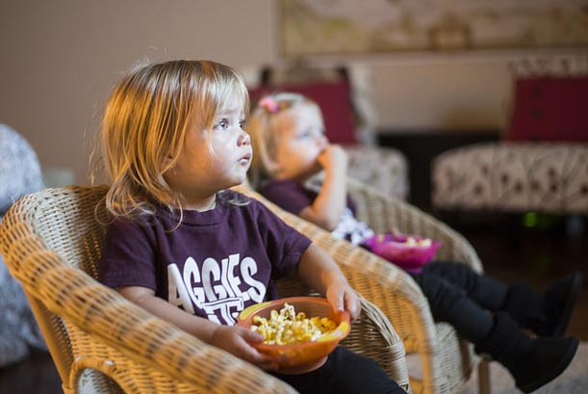

*Parents fighting*

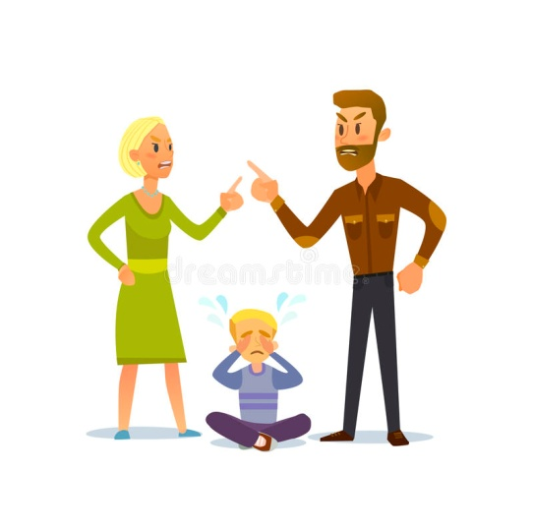

3. Explain to the class that an important sign of stress is a negative change in behaviour, for example, when someone loses interest in school activities, loses his or her appetite, or becomes aggressive and difficult.

4. Ask for some volunteers to explain what is happening in each picture and discuss each idea with the class:

|  |  |
| --- | --- |
| a. Feeling sad | Risultati immagini per bambino triste disegno |
| Risultati immagini per bambino disordinato | b. Being untidy |
| c. Fighting with other students | Immagine correlata |
| Immagine correlata | d. Sleeping in class |

5.Explain to learners that the negative feelings they have named are what is known as stress. These feelings are brought about by unpleasant or unhappy situations like the ones in the pictures. These situations are called ‘stress-causing situations.

Stress can sometimes affect us without our knowing it.

Therefore, it is important to be able to recognise signs of stress in ourselves so that we can get help when we need it.

**HOW TO EVALUATE THE ACTIVITY:**

A week after the "Signs of Stress" exercise, reproposes images of other stressful situations and images of situations that represent the consequent inconveniences (sadness, fatigue, litigation / anger, etc.).

Ask to "match" the situations identified with the representations of the relative inconveniences.

### А COUPON FOR ANY OCCASION

**OBJECTIVES: SUGGESTED AGE GROUP:** pupils age 6-7 year old

* Developing speaking skills for pupils;
* Developing good relationships, both between students and between teacher and pupils;
* Putting the game at the center of learning English.

**WHEN TO IMPLEMENT THE PRACTICE DURING DIDACTIC PROCESS:**

These activities are appropriate for the end of the lesson. This will create the basis for new student relationships.

**METHODOLOGY:**

Students will perform the various activities described on the coupons. This includes reading, talking, singing, dancing and even eating a favourite meal.

**FORM OF WORK:**

Each week will be given the opportunity to participate in the whole class.

**NEEDED MATERIALS:**

Required materials are: paper, coloured pencils, pens, coloured paper, scissors and whiteboard markers.

**DESCRIPTION OF THE ACTIVITY:**

Every week, different students will choose one coupon on which the activity that the class has to perform is drawn and described. This can be reading a favourite book, a favourite dance, a day without homework, a day to chew gum, presenting a favourite sport, a favourite movie, a day of stuffed toys, and so on.

**HOW TO EVALUATE THE ACTIVITY:**

Students will have the opportunity to be given the role of teachers for one day and will be able to make their own assessments.

**COMMENTS FOR IMPLEMENTATION** (if possible)

These activities can also be used after the end of the project.

* **Coupons in the Annex No.1**

### WORD TENNIS

**OBJECTIVES**  **SUGGESTED AGE GROUP**: pupils age 6-7 years old

* to improve students vocabulary.

**WHEN TO IMPLEMENT THE PRACTICE DURING DIDACTIC PROCESS:**

Common practice.

**METHODOLOGY:**

Pair work.

**FORM OF WORK:**

Pairs working together.

**NEEDED MATERIALS:**

Pictures.

**DESCRIPTION OF THE ACTIVITY:**

1. Pairs of students face each other.

2. The teacher gives one picture to each pair.

3. Based on the picture student one must say a word; once the word is said, then student two must say a new word. There is only one rule: the word they say must not start with the same consonant or vowel.

4.The teacher monitors and the word tennis goes until one student fails to say a word related to the picture keeping in mind the rule.

**HOW TO EVALUATE THE ACTIVITY:**

Active monitoring from part of teacher is needed to evaluate the success of the activity. The teacher needs to give a value from 1-5 (5 being the best) to the particular activity following each class. At the end of the month a mean score is obtained and that can be a good indication as to how this activity works. Twice each month somebody outside of the class (a colleague) needs to be asked to evaluate the activity on the same scale. Their mean score then has to be compared to the one given by the teacher themselves.

### OUT OF CHAOS-POLIS – The rules for well-being together

**OBJECTIVES**  **SUGGESTED AGE GROUP**: pupils age 6-7 years old

* INTERPERSONAL COMMUNICATION – SOCIAL SKILLS

Social abilities allows implementing behaviours useful to live harmoniously with other people.

The presence of rules gives children a perception of stability and order in the world they live. This is an essential factor for developing their safety.

An adequate and competent behaviour is at the base of our personal and social well-being, because it positively influences the perception of ourselves and of other people and the way we are perceived by others.

**WHEN TO IMPLEMENT THE PRACTICE DURING DIDACTIC PROCESS:**

Additional activity and common routine.

**METHODOLOGY:**

Story-telling, Circle-time, Role-playing, Game with awards.

**FORM OF WORK:**

Whole class.

**NEEDED MATERIALS:**

* Posters and markers;
* Sheets of paper and pens;
* Tokens;
* Medals;
* Notebooks;
* Little material awards (sweets and candies, writing and drawing materials, little toys etc.).

**DESCRIPTION OF THE ACTIVITY:**

*Aims*

- Increasing children’s awareness on positive and negative behaviours and on their consequences on relationships with other people.

- Increasing children’s awareness on importance of rules for a positive coexistence.

- Encouraging in children an adequate and competent behaviour both at school and out of school.

*Realisation of activities*

To start the activity, teacher reads to pupils the short novel of Chaos-polis (see Annex 1).

At the end of the tale, children are encouraged to help the Magician *Iknoweverything* finding a solution to the big confusion described in the tale.

To find and share solutions, teacher uses the circle-time: pupils place in circle and teacher solicits and manages the debate in a prearranged period.

The Circle time simplifies and increases circular communication, supports self-knowing, promotes a free and active expression of ideas, opinions, feelings and personal life experience; it originates a mood of calm and sharing.

Teacher invites pupils to sit down in circle and to find solutions, after they have identified wrong behaviours in the tale.

Teacher can also use dramatization (role-playing) in order to promote awareness about the necessity of rules.

Two pupils go in the centre of the classroom: one of them mimes a wrong action, the other one its opposite. The other pupils have to identify what is the right and what is the wrong behaviour.

At the end, teacher proposes to children to transform the right behaviours in rules to be respected. This will allow social abilities to become acted behaviours.

So the class will decide together the rules and will identify the specific behaviours to be implemented in order to respect these rules.

Rules have to be very well descripted and have to be related to positive behaviours.

It is very important:

- agreeing on the rules, so they can be shared as much as possible

- choosing a limited number of rules

- using action verbs for describing the rule

- describing the rule always in a positive way

- choosing measurable behaviours

- splitting the rule’s respect and the connected behaviours in little steps

- explaining rules and behaviours and sharing them with children.

It is important to identify specific behaviours and to accurately describe what children are expected to do and what teacher are expected to do (see Annex 2 and Annex 3).

Once rules and behaviours have been defined, teacher ask pupils to sign an agreement for each rule (see Annex 4).

Teacher and children decide together negative consequences for behaviours that disobey the rules and awards and gratifications for behaviours respecting them (repairing tasks, small penalties or medals, small awards etc.).

So fundamental steps are:

- identifying and sharing rules and behaviours

- teaching (with the role-playing)

- thinking about reasons (consequences)

- giving a positive and corrective feedback.

When rules are not respected, teachers do not have to reprimand or threaten: in this way children’s behaviours won’t change but actually the relationship with the child will end up souring.

Teachers have to scold and remind:

- referring to the poster where the rule is displayed

- asking the class and remembering together the shared rule and behaviours

- bringing out the agreement signed by the pupil.

It is important to inform families about these school activities; a short letter on behalf of every child (see Annex 5) could do it.

At the end of the role-play children explain thoughts and emotions they experienced during the activity; the rest of the group take part to discussion explaining their own opinions and ideas.

ANNEX 1

**The tail of Chaos-polis**

In the country of Chaos-polis children decided to live without rules.

They went to school when they wanted; if something was not to their satisfaction, they broke it; they opened windows and leaned out; they walked on desks, screamed at the top of theirs lungs and rolled around on the ground.

Teachers were desperate, because they couldn’t give lessons and they didn’t know what to do.

So they decided to ask a magician named *Iknoweverything* for help; he as very wise and could solve also very difficult problems.

But also *Iknoweverything* said the situation was really too difficult!

Let’s try to help him!

ANNEX 2

**Definition of rules, path and tools**

TOKENS

(FIRST TERM)

5 tokens for every child at the beginning of every day:

- 1 for every rule agreed and not respected

+ 1 for every positive behaviour

⇨ opportunity to recover the lost tokens.

At the end of the day, awarding of a little star on a poster to children who have preserved the 5 tokens.

At the end of the week, awarding of a prize to children who have all the little stars.

SECRETS’ NOTEBOOK AND MEDALS

(SECOND TERM)

As an integration and a progressive elimination of tokens, teachers introduce a Secrets’ Notebook, in which children could draw, tell and paste the “credit medals” obtained for the positive behaviours.

Material reinforcement is gradually given up instead of social reinforcement.

Setting and sharing “REPARING TASKS” as penalties for negative behaviours that keeping happening during the day.

**LISTENING**

PATH AND TOOLS

**WORKING**

**SILENTLY**

**SOCIAL ABILITIES**

**TALKING AT YOUR TURN**

**RESPECTING OTHER PEOPLE**

ANNEX 3

**Description of the rule and of behaviours to be acted for respecting it (example)**

|  |  |
| --- | --- |
| **LISTENING** | LOOK AT THE PERSON WHO’S TALKING WITH YOU |
| Immagine correlata |
| CLOSE YOUR MOUTH |
| Risultati immagini per illustrazione BOCCA CHIUSA |
| STOP YOUR HANDS |
| Immagine correlata |
| LISTEN WHAT THE PERSON IS SAYING TO YOU |
| Immagine correlata |

ANNEX 4

**Definition of the specific rule with regard to the expected behaviours (example)**

|  |  |  |
| --- | --- | --- |
| **RULE**  Enter in the classroom | **WHAT PUPILS ARE EXPECTED TO DO**  Enter in the classroom with calm and talk quietly.  Place their stuff.  Sit at their own seat. | **TEACHER’S TASKS**  Stand up in front of the classroom’s door.  Wait that pupils are all came in the classroom and then start to talk with them.  Decide where children could place their stuff.  Decide how to set desks.  Give value to pupils’ right behaviours. |

ANNEX 5

**The agreement**

I ____________________________________________________

(name of the child)

undertake to follow and respect the shared steps for

__________________________________________________________

(insert the specific rule)

I will receive a medal every time I will properly keep the behaviour.

Signature _________________________________

An example:

Io Marco Rossi

undertake to follow and respect the shared steps for work silently.

I will receive a medal every time I will properly keep the behaviour.

Signature _________________________________

ANNEX 6

**Letter to parents**

Dear parents,

in this period at school we are learning some social abilities that will help us to better compare with our classmates and to become friends.

We have prepared an action plan.

The abilities we practice can be implement both at school and at home.

I will write on my notebook the name of the ability and the steps to acquire it.

You can help me encouraging me to implement the abilities and reminding me to put a mark on my notebook every time I succeed.

Teacher will paste a medal on my notebook every time I will work hard for behaving as we have agreed.

I need you to encourage me to conduct this effort; with your help, I will become a super child!

Thank you mum, thank you dad *(or Thank you mums or Thank you dads).*

Your child _________________________

### DESERT ISLAND

**OBJECTIVES:** **SUGGESTED AGE GROUP:** pupils age 8-9 years old

Thanks to the implementation of the exercise, pupils:

1. develop the ability to cooperate in a group;
2. develop the skill of interpersonal communication;
3. develop the skill of creative thinking and creativity (sharing ideas, selecting the best ideas and their implementation);
4. develop the entrepreneurial skills:
5. integrate in the group.

**WHEN TO IMPLEMENT THE PRACTICE DURING DIDACTIC PROCESS:**

The exercise can be carried out at the beginning of the didactic process (but in a group of pupils that already know each other) as an integration exercise.

**METHODOLOGY:**

Expressive and practical methods;

Techniques: Interactive games and activities.

**FORM OF WORK:**

Work in a small groups (of 4-5 pupils).

**NEEDED MATERIALS**:

Art materials: markers, crayons, tape, paper (large sheets), A4 paper, coloured paper, etc..

It is recommended that the activity should take place in a room ensuring the free work of several groups - so that the groups can talk freely and do not interfere with each other.

**DESCRIPTION OF ACTIVITY**:

1. The teacher divides the group into smaller 4-5-pupils teams.
2. The teacher informs the children that on the time of this exercise they are on a deserted island. Their job is to organize life on this island. Pupils in 4-5-person teams have to prepare:

* The name of the island;
* Map of the island;
* Hymn of the island;
* Island costumes (each team member must be dressed in this outfit);
* Task division: e.g. who cooks, who cares for buildings, etc. Each person in the group must have a task assigned (e.g. according to what he/she likes to do, his/her interests).
* The rules of living on the island.

Time for the task 45 - 60 minutes.

1. Then each group presents their island by telling about it, presenting the prepared works (name and map of the island, costumes, singing the hymn, etc..)

**HOW TO EVALUATE THE ACTIVITY**:

Pupils answer questions:

• How did you like the presentations of other groups?

• What surprised / interested you in the islands of other groups?

• How did you cooperate in your team?

• Did everyone have a task assigned?

• What was important to you when carrying out this task?

**COMMENTS FOR IMPLEMENTATION** (if possible)

During the implementation of the task, groups may need support, guidance, inspiration, example.

The teacher should watch closely the work of the groups, so that each of the group members is involved in the implementation of the exercise.

### THERAPEUTIC FAIRY TALE

**OBJECTIVES:** **SUGGESTED AGE GROUP:** pupils age 8-9 years old

Thanks to the implementation of the exercise, pupils:

* strengthen their skills, including in cooperation skills, interpersonal communication, conflict management;
* pay attention to the aspect of personal culture in relations with other people;
* learn about different aspects of conflict situations - the importance of interpersonal communication in conflicts;
* they will reflect on the importance of emotions in a person's life.

**WHEN TO IMPLEMENT THE PRACTICE DURING DIDACTIC PROCESS:**

Activity can be implemented during the didactic process as a complement to the topic of mutual kindness, personal culture, dealing with emotions. In a special situation the activity can be carried out a few days after the conflict between the children.

**METHODOLOGY:**

Expressive and practical methods;

Techniques: Interactive games and activities.

**FORM OF WORK:**

Individual work.

Group discussion.

**NEEDED MATERIALS**:

The content of the fairy tale *"Warm and fluffy"* for the teacher, A4 sheets, markers, crayons, pastels.

**DESCRIPTION OF ACTIVITY**:

The teacher tells pupils that now he/she would like to invite them to listen to a story and asks them to sit comfortably. Then he/she tells the fairy tale about *"Warm and fluffy"* with a calm voice.

*"Warm and fluffy"* / unknown author */[4]*

*„A long time ago, far away, there was a good city. Its inhabitants lived happily, laughed, had fun and never got sick. In this city there was a lot of warm and fluffy. It was soft, fluffy, very light and pleasant to touch. People used to have such a habit that when they met with each other, they shared a warm and fluffy saying: "Warm and fluffy for you and warm and fluffy for me, warm and fluffy for me and warm and fluffy for you". And when they shared, warm and fluffy grew and there were even more of it. It lasted so long and people learned that when warm and fluffy grows their lives become more beautiful, hearts fill with love, and the body is healthier.*

*One day a witch came to the happy city. The witch travelled all over the world and sold her spells and medicines to people. However, in a good city no one wanted to buy medicine and did not need spells, because everyone was healthy and happy.*

*The witch walked around the city watching people and their customs and did not understand why she could not sell anything. After some time she realized that it’s because of warm and fluffy. Once, watching how people share it, she decided to free them from warm and fluffy and said to one of the residents: "You know? This warm and fluffy, which you got from your friend, it was not his warm and fluffy at all. He gave you only what he got from you yesterday". And to another inhabitant she said: "Did you notice that your neighbour gave you yesterday less warm and fluffy than you gave him?”*

*She circled the city until she poisoned people's hearts and people looked at each other warily. Less and less often they shared a warm and fluffy and kept them in their homes  
and drawers, jealously guarding it and afraid of losing it. And warm and fluffy, which no one shared, was less and less.*

*One day, the witch gave one of the inhabitants a little cold and spiky and said: "Cold and spiky for you and cold and spiky for me, cold and spiky for me and cold and spiky for you". And the cold and spiky grew. People began to share the cold and spiky with each other. There were diseases, happiness began to disappear from a good city, and people became sad and unpleasant to themselves. Days, months and years passed. The witch sold her medicines to people and became richer and richer. When she needed more money she shared cold and spiky with people, and then people got sick more and came to her for medication.*

*Fortunately, two children playing with each other in the attic found in the old chest warm and fluffy, which adults hid long ago, so that no one would take it away. When children watched it, they ripped it apart and divided it among themselves. And warm and fluffy immediately grew, and the children felt that some joyful note appeared in their hearts. They ran to their parents and shared with them saying, “Warm and fluffy for you and warm and fluffy for me." And the warm and fluffy grew again.*

*From that moment, people began to share the warm and fluffy with each other again and more happiness and joy appeared in their hearts, and the bodies were less ill. Then they remembered the old custom and old times. They drove out the evil witch and tried to share as much warm and fluffy as possible. However, there was also a cold and spiky in their town, which had once been given to them by a witch.*

*And from then on, warm and fluffy circulates among people alternately with cold and spiky and it depends only on people what they share with each other. And what they share will grow, filling their hearts and thoughts.”*

A moment after the story ends, the teacher gets up and walks with his/her hands arranged in such a way as if he/she was holding something in them and symbolically gives it to the one of the children and tells "Warm and fluffy for you" and asks to pass it on to other children. When the whole group transfers "Warm and fluffy", the teacher asks questions:

* What is "Warm and fluffy?" (What does symbolize this?)
* What is "Cold and spiky?"
* "What graphic symbol could describe Warm and fluffy as well as Cold and spiky?" – children draw their ideas on the papers and present them in the class;
* What feelings accompanied people when they shared "Warm and fluffy"? - pupils exchange positive feelings and write them on a large piece of paper. They repeat the same exercise with negative feelings.
* What a moral comes from this fairy tale?

After answering, each pupil gets up and says something nice to the person on the right.

**HOW TO EVALUATE THE ACTIVITY**:

Pupils answer questions:

* What “warm and fluffy” did you give to your loved ones today?
* What did you give yourself?
* How often does it happen?

### FAIRY TALE ABOUT FEELINGS

**OBJECTIVES:** **SUGGESTED AGE GROUP:** pupils age 8-9 years old

Thanks to the implementation of the exercise, pupils:

* get to know different emotions;
* will reflect on the essence of emotions in a person's life.

**WHEN TO IMPLEMENT THE PRACTICE DURING DIDACTIC PROCESS:**

Activity can be carried out during the educational hour, while discussing the topic of emotions with pupils.

**METHODOLOGY:**

Expressive and practical methods;

Techniques: Interactive games and activities.

**FORM OF WORK:**

Individual.  
Group discussion.

**NEEDED MATERIALS**:

The content of *a fairy tale about feelings* for the teacher.

**DESCRIPTION OF ACTIVITY**:

The teacher tells pupils that now he/she would like to invite them to listen to a story and asks them to sit comfortably. Then he/she tells a fairy tale about feelings with a calm voice.

*„Fairy tale about feelings”[5] (unknown author)*

*Once upon a time, there was an island in the ocean, which was inhabited by emotions, feelings and human qualities - such as good humour, sadness, wisdom, pride; and all of them were combined by Love. One day the inhabitants of the island found out that soon the island would sink. They prepared their ships to sail out to sea to leave the island forever.*

*Only Love decided to wait until the last moment. When only a tiny piece of land remained - Love asked for help.*

*The first swam closer the Wealth on his luxury yacht. Love asked:*

*- Wealth, can you save me?*

*- Unfortunately not. The deck is full of gold, silver and other valuables. There is no place for you anymore. - Wealth answered.*

*The second one swam the Pride with his huge four-masts ship.*

*- Pride, take me with you! - asked Love.*

*- Unfortunately, I cannot take you! Everything is organized on my ship, and you could spoil it ... - answered the Pride and proudly raised beautiful sails.*

*Sadness swam up on the rotten boat.*

*- Sadness, take me with you! - asked Love.*

*- Oh, Love, I am so sad that I want to remain alone. – the Sadness replied and sadly rowed in the distance.*

*Good humour sailed past Love without noticing her because he was so amused that he did not even hear a call for help.*

*It seemed that Love would die forever in the depths of the ocean ... Suddenly Love heard:*

*- Come! I will take you with me! - said the old man.*

*Love was so happy and grateful for saving her life that she forgot to ask who her saviour was. Love really wanted to know who this mysterious old man is. She asked Knowledge for advice.*

*- Tell me, please, who saved me?*

*- It was Time. - Knowledge answered.*

*- Time? - Love was surprised. - Why did Time help me?*

*- Only Time understands how important love is in the life of every human being. - Knowledge said.*

**HOW TO EVALUATE THE ACTIVITY**:

Pupils answer questions:

* What does this story teach us?
* Why are feelings important in our lives?

### THE MIME GAME

**OBJECTIVES:** **SUGGESTED AGE GROUP:** pupils age 8-9 years old

* Interpersonal communication;
* To enable students to distinguish between verbal and non-verbal communication.

**WHEN TO IMPLEMENT THE PRACTICE DURING DIDACTIC PROCESS:**

Common routine.

**METHODOLOGY:**

Team game.

**FORM OF WORK:**

In groups.

**NEEDED MATERIALS:**

Instructions for non-verbal communication written on pieces of paper and rolled up.

**DESCRIPTION OF THE ACTIVITY:**

1. Divide the students into two groups and call upon one student from each group to come out in turn and draw lots. He or she should obey the instructions written on the paper and communicate something to the class (*see Instruction below*). Ask the other group to watch the student and find out what the instructions were. If they could guess correctly, give them 1 mark.
2. Ask every student from each group to draw lots in turn until all the lots have been drawn and the instructions carried out.
3. Decide which group has won.
4. The teacher should ask the following questions.
5. How did the students who drew lots act?
6. What gestures did they make?
7. What parts of the body did they use when they acted?
8. Explain that in addition to speech, facial expressions, gestures and movements of arms and legs may be used to convey one’s feelings or message to the other person. Such use is called non-verbal communication.

In everyday communication, however, speech is usually used to communicate. This method of communication is called verbal communication.

**HOW TO EVALUATE THE ACTIVITY:**

Ask students to identify and mimic a situation related to a sentiment of their choice.

You will be able to evaluate the effectiveness of this exercise by looking at the concepts that students try to communicate through gestures and facial expressions. This activity will allow you to understand if the value of non-verbal communication has been understood and the possibility of externalizing one's own moods without using words.

* **Additional material**

Instructions

1. Press your head and make a grimace. (Has a stomach head)
2. Yawn and put your hand in front of your mouth. (Feels sleepy)
3. Look up at the sky and snorts (Feels bored)
4. Look around and bar the eyes (feels lost)
5. Look around and your forehead frowns (Looks for someone)
6. Hold the chin with your hand (thinks)
7. Dry your eyes with your hands (Feels sad)
8. Cover your face with your hands (Feels worried)
9. Raise your arms up in victory and smile (Feels satisfied)
10. Make a grimace and shake your hands. (Does not agree)
11. Frown and scratch your head. (Does not understand)
12. Laugh heartily. (Feels pleased)
13. Stare. (Is surprised)
14. Sob. (Is sorrowful)

### CLASS CALENDAR

**OBJECTIVES: SUGGESTED AGE GROUP:** pupils age 8-9 year old

* Developing reading and speaking skills for pupils;
* Developing good relationships, both between students and between teacher and pupils.

**WHEN TO IMPLEMENT THE PRACTICE DURING DIDACTIC PROCESS:**

These activities are appropriate for the beginning of the lesson / day. This will create a good mood and students will concentrate more easily for the rest of the day.

(integration of a class, starting a lesson/day, evaluation of a day, additional activity, common routine, in case of unexpected situation…)

**METHODOLOGY:**

The methodology is based on various activities. Students will paint, sing, play, read and write.

(drama, art activity, Edward de Bono’s methods…)

**FORM OF WORK:**

Each week will be given the opportunity to participate in the whole class.

(individual, in pairs, in groups, whole class)

**NEEDED MATERIALS:**

Required materials are: paper, colored pencils, pens, colored paper, scissors and whiteboard markers.

**DESCRIPTION OF THE ACTIVITY:**

Each month has a different theme with great prompts, questions, and inspiration for you and your students. The students will begin the lesson in English by reading the assignment for that day from the calendar. Then the teacher gives the students the opportunity to say what they think about the question. The questions are different. There are also fun tasks, challenges etc. It is important for students to wish to participate. The goal is not to worry about speaking and expressing their opinion.

**HOW TO EVALUATE THE ACTIVITY:**

The evaluation of this activity will take place at the end of each month. Since the entire class will participate, it is logical for students to be encouraged with appropriate prizes. Certificates for reading, speaking, drawing, singing, good attitude towards others will be prepared. At the end of the school year a short celebration, prepared by the students and the teacher, can be made.

**COMMENTS FOR IMPLEMENTATION** (if possible)

These activities can also be used after the end of the project.

* **Calendar in the Annex No. 2**

### COMMON HEADS

**OBJECTIVES SUGGESTED AGE GROUP:** pupils age 8-9 years old

* Interpersonal communication.

**WHEN TO IMPLEMENT THE PRACTICE DURING DIDACTIC PROCESS:**

Common routine.

**METHODOLOGY**:

Team game.

**FORM OF WORK:**

In groups.

**NEEDED MATERIALS:**

Instructions for non-verbal communication written on pieces of paper and rolled up.

**DESCRIPTION OF THE ACTIVITY:**

1. The teacher gives a problem to be solved .

2. All students in the team answer the question on their own recording document. At this time the teammates should not see what the student is writing down. Also no talking is allowed at this stage.

3. When all teammates have finished jotting down their answers, the teacher says, "Common heads!"

4. All students share their answers and discuss. They must agree on one answer.

5. The students in the group must pick papers with numbers on them. The student with the highest number must report the answer to the class.

**HOW TO EVALUATE THE ACTIVITY:**

Active monitoring from part of teacher is needed to evaluate the success of the activity. The teacher needs to give a value from 1-5 (5 being the best) to the particular activity following each class. At the end of the month a mean score is obtained and that can be a good indication as to how this activity works. Twice each month somebody outside of the class (a colleague) needs to be asked to evaluate the activity on the same scale. Their mean score then has to be compared to the one given by the teacher themselves.

### I CHOOSE!

**OBJECTIVES SUGGESTED AGE GROUP:** pupils age 8-9 years old

* INDEPENDENT AND CRITICAL THINKING

Activities are aimed at developing and improving critical thinking in children of primary school.

Critical thinking means opportunity of choosing, but also of changing a not functioning or dangerous behavior.

The following activities want to encourage individual and collective thinking and the consequent level of choice, considering external world influences.

**WHEN TO IMPLEMENT THE PRACTICE DURING DIDACTIC PROCESS:**

Additional activity and common routine.

**METHODOLOGY**:

Practical laboratory; role-play.

**FORM OF WORK:**

Whole class.

**NEEDED MATERIALS:**

* Sheets of paper and pens;
* Posters and markers;
* Images and photos of objects connected to children’s world.

**DESCRIPTION OF THE ACTIVITY:**

*Aims*

* Increasing children’s awareness on their relationship with things and objects.
* Identifying and recognising individual diversities in tastes and opinions, that determine choices and use of things and object.
* Understanding the mass media and advertisement “pressing” and their conditioning (in particular children) for an uncritical consumerism that is fast, gratifying and social identifying.

*Realisation of activities*

Children chose together some products and objects they consider trendy (for example bags, clothes, toys, video games etc.).

Each pupil drafts a form, inserting each objects in one of the following categories:

* essential objects,
* important objects,
* unnecessary objects.

Then pupils compare their forms and confront with each other.

Activities go on with a role play: children perform situations in which the selected objects are not desired or not accessible: actors play characters who don’t adapt to trends and have a personal style or characters who have to resist to group pressures or characters who can’t obtain desired objects.

At the end of the role-play children explain thoughts and emotions they experienced during the activity; the rest of the group take part to discussion explaining their own opinions and ideas.

**HOW TO EVALUATE THE ACTIVITY:**

The form allows several considerations about individual and group identity, personal tastes and preferences, homogenisation caused by trends and advertising.

Role-play is useful to collect considerations and opinions about sensations, group judgment, emotions, group creativity, alternative thoughts etc.

### SNAKES AND LADDERS FOR KNOWING EACH OTHER

**OBJECTIVES SUGGESTED AGE GROUP:** pupils age 8-9 and 10-11 years old

* INTERPERSONAL COMMUNICATION – SOCIAL SKILLS

One of the most urgent problem of our complex society is learning to live together and considering differences as a treasure, an opportunity of growing for everyone.

Social skills are essential for inclusion and education, tolerance and acceptation of others.

The capacity of creating and keeping interpersonal relations helps everyone to develop healthy social contexts as places of constructive interactions, in which people can learn to preserve relationships but also to positively elaborate and pass a relation’s end.

**WHEN TO IMPLEMENT THE PRACTICE DURING DIDACTIC PROCESS:**

Additional activity.

**METHODOLOGY:**

Game, Cycle time.

**FORM OF WORK:**

Whole class.

**NEEDED MATERIALS:**

Game board; Pieces; Dice; Game cards.

**DESCRIPTION OF ACTIVITY:**

*Aims*

Proposed activities aims at increasing children’s awareness of the relational network and of the meaning it has in their everyday life, in which relationships (depending on “how much” they are and “how” they are) produce wellness and serenity.

So actions aim at:

* leaning children to communicate and interact with each other,
* helping children to know their own and other’s qualities that can support the developing of pleasant relations.

*Realisation of activities*

It is the classic “Snakes and Ladders” game: each player, in his/her turn, rolls the dice and advances on the game-board (see Annex 1) for a number of squares in the amount of the number come out.

Then he/she reads the card (see Annex 2) that corresponds to the square’s number and carries out what the card says.

Game goes on up to the finish line.

At the end of the game, children are invited to a cycle-time, in order to answer some questions:

* what have I discovered about others that I didn’t know?
* what have I let others learn about me?
* what do I like of others?
* in what would I like to be similar to others?
* in what would I like others were similar to me?

ANNEX 1

**Game board**

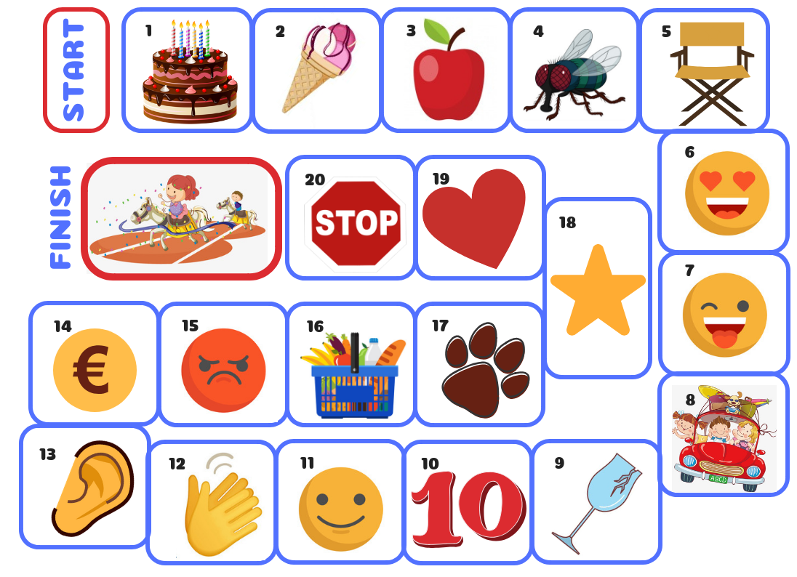

ANNEX 2

**Game cards**

|  |  |  |  |
| --- | --- | --- | --- |
| **1**  In which month have other participants their birthday?  If you make more than 2 mistakes move back to the Start square. | **2**  Choose a member of the group and try to guess his/her favourite ice-cream taste  (before you say it, let him/her tell it to another person in the group).  If you get wrong, move back one square. | **3**  Choose a member of the group and try to guess his/her favourite fruit  (before you say it, let him/her tell it to another person in the group).  If you get wrong, move back one square. | **4**  Close your eyes and turn around. Just one person lightly touch your back and you have to guess who he/she is.  If you get wrong, move back one square. |
| **5**  You have been rude with other people: stay seated on the chair for a round. | **6**  Say a good quality of each participant. | **7**  You are a little sad: ask each participant to make a funny face. | **8**  Tell a pleasant experience you have had out of the school. |
| **9**  Someone has broken a glass during the lunchtime: stay for a round. | **10**  You have obtained a beautiful mark or realised a particularly laborious work and the whole class celebrate you.  Advance 2 squares. | **11**  Close your eyes and do not cheat.  One of the group goes in front of you. Just touching his/her face, you have to guess who he/she is.  If you get wrong move back to the square you come from. | **12**  Close your eyes and do not cheat.  One of the group goes in front of you. Just touching his/her hands, you have to guess who he/she is.  If you get wrong move back to the square you come from. |
| **13**  Close your eyes and do not cheat. One of the group whispers in your ear “Peter Piper picked a peck of pickled peppers. How many pickled peppers did Peter Piper pick?” (or another different tongue twister). You have to guess who he/she is.  If you get wrong move back to the square you come from. | **14**  There is an unexpected award for you.  Advance 2 squares. | **15**  There is a quarrelling atmosphere. Stay for a round to let things cool down. | **16**  Say what’s the food you especially like to buy doing shopping. |
| **17**  If you were an animal you’d be …  Explain why. | **18**  Tonight you don’t want to go to sleep.  Move back to the square 14. | **19**  Complete this phrase with a rhyme:  “My class is a beautiful class …” | **20**  STOP!  Stop here! Wait the other players! Your trophy is too heavy, you need some help to raise it up and celebrate at least!  A shared victory is a double victory! |

### THERMOMETER OF FEELINGS

**OBJECTIVES:** **SUGGESTED AGE GROUP:** pupils age 10-11 years old

Thanks to the implementation of the exercise, pupils:

1. develop emotional awareness - develop the ability to recognize and name emotions;
2. develop the ability to pay attention to emotions in different situations, e.g. in conflict situations (they will pay attention to what the accumulation of negative emotions can lead to);
3. develop the need to express emotions and talk about their causes:
4. change the way of thinking about expressing emotions.

**WHEN TO IMPLEMENT THE PRACTICE DURING DIDACTIC PROCESS:**

The exercise can be completed at the end of the teaching process, as a summary of the topic of dealing with emotions. Also during conflict situations among pupils to teach them how to deal with such situations.

**METHODOLOGY**:

Expressive and practical methods;

Techniques: Interactive games and activities.

**FORM OF WORK:**

Individual work and work in small groups.

**NEEDED MATERIALS**:

* Worksheet with thermometer
* Crayons / markers

**DESCRIPTION OF ACTIVITY**:

1. Introduction to the subject of emotions. Discussion with pupils about what emotions pupils know, what are pleasant and what are unpleasant emotions. You can write emotions on the board.
2. Pupils work with a worksheet (worksheet in the attachment to the exercises).

The worksheet contains situations that can cause anger or other unpleasant emotions. Read them carefully. In a few windows you will find empty spaces - put in a different situation there, in which you still feel anger or other unpleasant emotions.

On the right side you can see a thermometer on which, using colours, you can determine how much emotion you feel when you encounter each of these situations.

Now try to remember how you felt in the situations described in the window. Then, colour the intensity of the emotion that you think is appropriate with the right colour.

Colour the thermometer with colours that mean:

**6**

Leave me alone!

**5**

I’m feeling agressive!

**4**

I’m starting to feel angry!

**3**

I’m beginning to feel unhappy!

**2**

I’m feeling anxious!

I’m feeling calm!

1. Discussion and presentation of pupils' work - it can be implemented in small groups.

**HOW TO** **EVALUATE THE ACTIVITY**:

Discussion with pupils:

* What causes accumulation of anger and other unpleasant emotions?
* When can the "explosion" of emotions take place?
* Is this "explosion" always adequate to the situation?
* What are the ways that these emotions do not increase? (For example: conversation - when we talk about feelings, especially those unpleasant - this is a way to release them, to catch a breath).

**COMMENTS FOR IMPLEMENTATION** (if possible)

A PowerPoint presentation presenting a thermometer of emotions – an increase of emotions up to an explosion, can in a vivid way show the growing of emotions.

When something does not come out.

When I have to wait long for something.

When someone does not want to do what I am asking for.

When I do not understand something.

When somebody takes something what is mine.

When someone yells at me.

When someone laughs at me.

When someone criticizes me.

When I lose.

### WHERE IS THE STRESS?

**OBJECTIVES:** **SUGGESTED AGE GROUP:** pupils age 10-11 years old

Thanks to the implementation of the exercise, pupils:

* will be able to define stress;
* will know where stress can be placed in the human body;
* learn how to deal with stress.

**WHEN TO IMPLEMENT THE PRACTICE DURING DIDACTIC PROCESS:**

Exercise can be done during the educational hour, or during the didactic process, when there is such a need, e.g. a few days after the situation that aroused strong emotions of pupils, to show them the consequences of, for example, stress and show ways to deal with stress.

**METHODOLOGY:**

Expressive and practical methods;

Techniques: Interactive games and activities.

**FORM OF WORK:**

Individual work.

Teamwork - in a large group.

**NEEDED MATERIALS**:

Large paper carton (approximately 150 - 170 cm X 80 -100 cm), multi-coloured sticky notes (large amount), markers, crayons.

**DESCRIPTION OF ACTIVITY**:

We divide the pupils into smaller groups of 4-5 people. Each team writes on the sticky notes the factors that cause stress. One factor on one note - it can also be represented symbolically, by drawing etc. This part is lasting for about 10 minutes. Then the pupils present their work - sticking the notes e.g. on the wall and immediately grouping them into certain categories such as stress at school, stress at home, stress related to building relationships, etc. depending on the proposals that pupils will have. To sum up this part of the exercise, we talk about what situations stress young people.

In the next stage, please apply for one volunteer. The pupil is placed on the large paper on the floor and the remaining pupils mark the contour of the lying person with a marker. In this way, one large outline of a human figure is created.

*Note: If the group is very large, it can be prepared several contours of a human figure and continue the entire exercise until a summary in smaller groups.*

|  |  |
| --- | --- |
| In groups, pupils wonder where in the body they experience stress the most. On a large human figure created, each group marks the places where we usually experience stress. It is important that each group has a different colour of the marker. (In the case of working in smaller groups, each pupil can have his own pen colour). |  |

The final stage of the exercise is to talk how people can deal with stress. Pupils share ideas - brainstorming - what can be done to deal with stress or how to prevent escalation of emotions.

*Examples from the teacher (if pupils do not tell them), for example, crush a sheet of paper as their anger and throw it into the bin.*

**HOW TO EVALUATE THE ACTIVITY**:

Pupils answer questions:

* Where is the stress (or negative emotions) placed in the body?
* How can you deal with this stress?
* What did you learn during the activity?
* Did something surprise you during activity? (If yes: What was it?)

**COMMENTS FOR IMPLEMENTATION** (if possible)

The exercise can be supplemented with theoretical content: We talk about various somatic reactions, emotional reactions and ways of behaviour that are the result of stress.

The lecturer discusses various symptoms of stress:

* physiological symptoms,
* emotions in the sphere of emotions,
* symptoms in the sphere of correctness of thinking,
* behavioural symptoms,
* symptoms in the sphere of life philosophy.

Exercise can be carried out in an analogous form in relation to the topic of experiencing and dealing with strong emotions.

### THE TOWER

**OBJECTIVES:** **SUGGESTED AGE GROUP:** pupils age 10-11 years old

Thanks to the implementation of the exercise, pupils:

* develop planning and organizational skills;
* increase motivation to act - how competition influences the motivation to act;
* develop the skill of cooperation and interpersonal communication;
* develop their creativity.

**WHEN TO IMPLEMENT THE PRACTICE DURING DIDACTIC PROCESS:**

Exercise can be implemented during the educational hour.

**METHODOLOGY:**

Expressive and practical methods;

Techniques: Interactive games and activities.

**FORM OF WORK:**

Work in small groups (4-6 people)

**NEEDED MATERIALS**:

The amount of materials depends on the size of the group and the number of small teams (4-6 people). Each team should receive identical materials, e.g. 5 sheets for flipchart, 10 sheets of A4, 20 sheets of self-adhesive, 1 pair of scissors, two glues, 2 adhesive tapes.

**DECRIPTION OF ACTIVITY**:

We divide pupils into smaller teams of 4-6 people. It is important that the number of people in teams is the same. Each team has to build a tower. The task of the groups is to build the highest and stable tower that stands alone. In addition, the tower must stand on the floor, but it cannot be supported by any other elements of the room or equipment. For example, it cannot be supported by a wall, a chair, etc. A tower can only be built only from the received elements/materials. Time for the task is 30 minutes. At the time, pupils are devising a construction strategy and building a tower.

After 30 minutes, the teacher completes the exercise and all together evaluate the towers in terms of the criteria set out at the beginning.

**HOW TO EVALUATE THE ACTIVITY**:

Pupils answer questions:

* Are you satisfied with the effect of your work? What does it affect?
* How was the cooperation in teams? Has a leader emerged?
* How did you talk to each other? If the good achieved effect was supported by the communication between you? Why?
* How did you look for a solution? What were the ideas for building the tower?
* How did you build towers? Have you developed the tower building strategies at the beginning of the task? What did it relate to?
* Will you change something in your realization of the task now? If yes: What would you change?

**COMMENTS FOR IMPLEMENTATION** (if possible)

To make this activity more attractive, you can change the materials from which the tower is built. You can use, for example, drinking straws, pasta (e.g. spaghetti), etc. It all depends on the imagination and manual possibilities of pupils.

### WORDS FOR FEELINGS

**OBJECTIVES: SUGGESTED AGE GROUP:** pupils age 10-11 years old

* Emotional intelligence, empathy/copying with stress;
* To introduce the children to awareness of basics of feelings;
* To introduce the children to the ‘feelings chart’;
* To help children accept that it is natural to feel various emotions.

**WHEN TO IMPLEMENT THE PRACTICE DURING DIDACTIC PROCESS:**

Common routine.

**METHODOLOGY:**

General discussion.

**FORM OF WORK:**

Whole class.

**NEEDED MATERIALS:**

Black board and chalk, 2 chart papers and sketch pens, drawing paper, crayons.

**DESCRIPTION OF THE ACTIVITY:**

1. The facilitator begins by generating a discussion on feelings by asking questions such as, “How do you feel when someone gives you a present?” Write the “feeling word” given in the answer on the board (e.g. happy).

2. “How do you feel when your teacher tells you that you did a “good job”? Write the “feeling word” on the board. Continue eliciting feeling words from the group, writing the list on the board. This is a good opportunity to indicate some distinction between feelings and thoughts. For example: the question, “how do you feel when someone makes fun of you?” if answered with, “I think it is reprehensible behavior”, is a feeling question with a ‘thinking’ answer. An answer such as, “I feel angry” is a feeling answer, in response to the same question, demonstrating awareness of the feeling taking place and giving it recognition**.**

3. What are the names of the emotions/feelings you can think of? Ask the children to name all the ‘emotions’ or ‘feeling words’ they can think of. Simultaneously, separate feeling words from non-feeling words, in their list and also point out and explain the non-feeling words that may come up (The Facilitator may refer to the checklist of basic feelings).

4. On the chart, make the final list. Write it on a chart so that it can be preserved. Allow the children to copy the list in their Journals.

5. Put up the EMOTIONS CHART which has been prepared by you in advance.

Read aloud each incident/event and ask the children how many of them would feel sad or happy or other basic emotion if this happened to them. Make the children raise their hands and count hands and write the number(s) on the chart at the appropriate places. Discuss how people react differently and how it is okay to feel whatever you feel.

6. It may be also worthwhile to have the children choose a feeling word from the list (checklist of Basic Emotions) or even choose how they are feeling at that moment and draw a picture of that feeling and write it in the journal.

7. At first it is difficult for the children to get in touch with actual feeling and feeling words. With help and lots of examples, they soon become more aware and are eager to share. Getting in touch with their feelings gives them an opportunity to handle them and release them*.*

8. Ask the children to copy the chart of emotions into their note books/journals. At the end of the session the children have to draw a circle in their journal of how each of them “felt” about ‘Life Skills’ class which has being conducted as work.

**HOW TO EVALUATE THE ACTIVITY:**

The responses to the play provide an excellent opportunity to evaluate the success of the lesson. Students understanding of the subject matter should be clear from their discussion about how to respond to “Feelings Chart”.

* **Additional material**

***Check list of Basic Emotions****[6]*

* Fear → feeling of being afraid, frightened.
* Anger → feeling angry. A stronger word for anger is *rage.*
* Sadness → feeling sad. Other words are *sorrow*, *grief* (a stronger feeling, for example when someone has died).
* Joy → feeling happy. Other words are *happiness*, *gladness.*
* Disgust → feeling something is wrong or nasty.
* Surprise → being unprepared for something.
* Trust → a positive emotion; admiration is stronger; acceptance is weaker.
* Anticipation → in the sense of looking forward positively to something which is going to happen.



**Feelings chart**

|  |  |  |  |  |
| --- | --- | --- | --- | --- |
|  | **Emotion** | | | |
| **Incident** | Happy | Sad | Angry | ….. |
| In the family they scold me |  |  |  |  |
| I missed a task at school |  |  |  |  |
| I remain locked in a room |  |  |  |  |
| I lost a friend's gift |  |  |  |  |
| my friends do not listen to what I say |  |  |  |  |

### GOOD MORNING, CAPTAIN!

**OBJECTIVES: SUGGESTED AGE GROUP:** pupils age 10-11 year old

* Creating a positive classroom atmosphere of acceptance and tolerance between pupils;
* Helping pupils get to know each other better;
* Developing effective listening skills;
* Relieving stress and having fun at the end of the class.

**WHEN TO IMPLEMENT THE PRACTICE DURING DIDACTIC PROCESS:**

Additional activity at the end of the class.

**METHODOLOGY:**

Edward de Bono’s methods.

**FORM OF WORK:**

Whole class.

**NEEDED MATERIALS:**

Whiteboard markers.

**DESCRIPTION OF THE ACTIVITY:**

At the end of each lesson one of the pupils comes in front and turns its back on the class. He/she is the Captain. Three pupils are invited to describe themselves in 30 seconds. They may reveal whatever interesting information they decide except personal names. The point is that each Captain manages to guess who his/her three classmates are. If he/she succeeds in doing so, the whole class will sing for him/her “Raise your hands up in the air and for our Captain say hooray! HOORAY!!!

**HOW TO EVALUATE THE ACTIVITY:**

At the end of the school year the pupils will fill in a questionnaire including interesting personal facts about each one of them. They will have to guess and match the names of their classmates to the corresponding information.

**COMMENTS FOR IMPLEMENTATION**

When we create a positive classroom atmosphere, students learn better. Every student must feel safe and important in the class in order for maximum learning to take place. A positive classroom environment does not just happen; the teacher leads to it and helps the class with creating it.

### QUIZ MARKET

**OBJECTIVES: SUGGESTED AGE GROUP:** pupils age 10-11 years old

Cooperational competence:

* To teach children how to discuss learning material;
* To teach children how to assess each other.

**WHEN TO IMPLEMENT THE PRACTICE DURING DIDACTIC PROCESS:**

Common routine.

**METHODOLOGY:**

General discussion.

**FORM OF WORK:**

Whole class.

**NEEDED MATERIALS:**

Cards, pens.

**DESCRIPTION OF THE ACTIVITY:**

Cards can be made out of anything even fancy ones that are typed up and enhanced with clip art. A question is written on one side of the card and the answer is written on the other side. Each side needs to be labeled with 'Question' or 'Answer' for clarity.

How it Works:

Quiz market is an active structure in which students stand up, partner up, and quiz each other with questions. It appears simple at first glance, but social skills are incorporated in the structure.

1. Students find a partner, high five them and say, "Hi, partner!"

2. Student one questions student two using the question on their card. They hold the question side of the card to their partner and keep the answer side facing them. If the partner answers correctly, they receive a praise. If they answer incorrectly, they are given a hint.

3. Student two quizzes student one using the same process described above.

4. When both students have questioned each other, they high-five and say, "Bye, partner!" and they find a new partner.

**HOW TO EVALUATE THE ACTIVITY:**

Active monitoring from part of teacher is needed to evaluate the success of the activity. The teacher needs to give a value from 1-5 (5 being the best) to the particular activity following each class. At the end of the month a mean score is obtained and that can be a good indication as to how this activity works. Twice each month somebody outside of the class (a colleague) needs to be asked to evaluate the activity on the same scale. Their mean score then has to be compared to the one given by the teacher themselves.

### BODY SCAN

**OBJECTIVES:** **SUGGESTED AGE GROUP**: all ages

* Improves concentration and learning;
* Reduces stress, anxiety and depression;
* Improves creativity;
* Emotional regulation and care;
* Corporal awareness.

**WHEN TO IMPLEMENT THE PRACTICE DURING DIDACTIC PROCESS:**

It can be done at any time. Is a good practice to become relax and could be nice to do it at the end of the day. It is a practice that can be integrated as a common routine in your daily life.

**METHODOLOGY:**

Mindfulness applied in the school environment.

**FORM OF WORK:**

It’s an activity done Individually and with the whole class.

**NEEDED MATERIALS:**

You can put some relaxing music on the back of the exercise, and use a meditation bowl to mark the beginning and end of the activity. The sound of the bowl will help to go back to the present moment and students will associated with the state of meditation.

**DESCRIPTION OF THE ACTIVITY:**

**1) Lie down on your back in a comfortable position, on top of a blanquette or a matt.**  Let your legs and your arms relax on the sides of your body and close your eyes.

**2) Take 3 slow and deep breaths.** Connect with your body while you are breathing, feel how your belly or chest moves up and down, you can out a hand on top to feel the changes in your body while breathing.

**3) Focus your attention in your feet: how are your feet? Can you feel them? Are they relaxed? How is there temperature in your feet?** It’s also okay if you feel nothing at all. Put your intention in relaxing your feet and put a smile on them and thank them for all that they are able to do for you, walk, jump, move. Thank your feet both feet. If your mind gets distracted, is perfectly ok, just get back your attention to your feet again as you realize. There is nothing to do, nowhere to go, nothing to worry about, just rest on the floor and feel how it’s holding your entire body, hoe you can rest on the surface and feel the soft and gentle touch with the floor.

**4) Now we are going to put or attention on our legs, feeling them. What is their temperature?** Are they relaxed or tense? Feel how they are touching the blanquette and the pressure to the floor, fell your knees relaxing, letting them rest on the floor that are holding them. Make a smile with your face to your legs and your knees and thank them for all they do for you, they enable you to walk, to jump. Now you can speak to them and tell them you are grateful for all they do for you.

**5) Now move your attention to your belly.** Feel how is your belly, is the place where we have a lot of emotions. It normally moves up and down when you breathe, like the waves of the sea, coming up and down. You might feel like full or hungry, or something else, just let it be, whatever it is that is happening and breath it. Smile to your belly and thank it for all that is doing for you, all the organs that enable you to eat, digest, detox the body.

If you get distracted and cannot focus, that’s normal and it’s perfect as it is. Gently practice coming back again and again to how your chest and feel you breathe coming in and out.

**6) Now, bring your attention to your chest.** Feel the connection with your breathing, with the movement of your chest going up and down. Feel the air coming in and out of your lungs, your heart beat…

**7) Now turn your attention to your hands.** Feel how they contact the floor, you don’t have to do anything, just let them relax on the floor, let the floor hold them and Let them relax. Now smile to your hands, put a big smile on your face and thank your hands for all the things they do for you, eat with your folk, touch someone you love, hold a pencil etc.

**8) Move your attention into your arms.** And see if you can find a moment of stillness at the end of your breath. Feel your arms, if there’s any tension, if they are relaxed. And smile to your arms and thank them for all they do for you.

**9) Now go with your attention to your back. feel it touching the floor and notice how it rocks with each breath as a soft caress.** If you mind goes somewhere else, it’s perfectly ok, the mind normally does this, just go back to your back again. Whenever you feel your mind gets busy or worried you can take it back to your body, and the mind will get relaxed in the present moment.

**10) We go upwards to our neck and shoulders. Just by putting our attention on them we help them to get more relaxed. Help your neck and shoulders to relax, the hold so much all through the day. Give them a smile, and thank them for all they do for you during the day. They hold straight all your back and your head, take a moment to be grateful to them.**

**11) Now feel your face and your head.** Ow is your facial expression, do you feel relaxed? Relax your eyes, your mouth, your chicks. And give a smile to your head and face, and thank them for all they do for you. You can smile, eat, see, speak, think. Realize all you receive from them.

**12) Now pay attention to your whole body.** Check how your whole body is feeling right now. And accompany your breath coming in and out of your body. feel the gratefulness of having a body, if you don’t feel it, is also ok. Just let these words come into you.

You can **start to move your hands slowly, your feet, respecting the time your need for doing so time. And you can start opening your eyes when your feel ready, and slowly star to come back to a sitting position.**

**HOW TO EVALUATE THE ACTIVITY:**

The level of relaxation before and after the practice.

You can measure the pulsations before and after the practice.

### CONSCIOUS EATING

**OBJECTIVES:** **SUGGESTED AGE GROUP**: All ages.

* Improves focus, concentration and learning;
* Improves creativity;
* Enhances gratitude and happiness;
* Improves Comprehension.

**WHEN TO IMPLEMENT THE PRACTICE DURING DIDACTIC PROCESS:**

It can be done before eating something.

**METHODOLOGY:**

Mindfulness applied in the school environment.

**FORM OF WORK:**

Done individually but with the whole class at the same time.

**NEEDED MATERIALS:**

Something to eat, a raisin or another small food that is connected with nature.

**DESCRIPTION OF THE ACTIVITY:**

Before eating a raisin or something else, we make a pause to become aware and thank the people, places, and things that were part of its journey, from the tree to our table, and that enables us to eat this food.

1. We cover a raisin in a tissue and tell the class to close their eyes. We give a tissue with a raisin inside.
2. We tell them to open de tissue with eyes closed and sense with their hands what it’s inside, tell them to smell it.
3. We are going to visualize about how it got from the grapevine into our hands:

* We imagine the worms that nourished the soil… *Thank you, worms!*
* The sun, the rain that fed the vines, the time it took to grow, one day and another day... *Thank you, nature!*
* The farmers who took care of the vines and harvested the grapes… *Thank you, farmers!*
* The workers who harvested the grapes, put them out to dry, and boxed them up as raisins… *Thank you, workers!*
* The truck drivers who drove the raisins to the store… *Thank you, truck drivers!*

- The person who bought the raisins and brought them to you… (Children thank you.)

**4.** Now, let’s start eating the raisin slowly, being conscious of every bite, every flavour. Put it first in your mouth for a moment, without chewing, and notice what that feels like. Then spend a moment just chewing it. And, finally, swallow it. Pay careful attention to how each step feels.

**HOW TO EVALUATE THE ACTIVITY:**

Have you thought about your food this way before?

Do you think about raisins differently now?

### COUNTING BREATHS

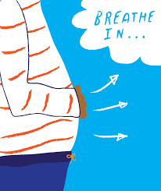In meditation or mindfulness, the attention on the breathing is one of the main focus. This attention on the breathing, will to help us to become more present and connected to the present moment, the Here and Now that is happening, and will enable us to access inner resources that will help us to become balance and self- empowered.

**OBJECTIVES:**

* Reduces stress and anxiety;
* Favours self-control;
* Helps emotional regulation;
* Develops concentration and focus.

**SUGGESTED AGE GROUP**: All ages

**WHEN TO IMPLEMENT THE PRACTICE DURING DIDACTIC PROCESS:**

It is a practice that can be integrated as a common routine at the beginning or at the end of the day. The more we practice, the more we’ll develop this connection with the body through the breathing and learn to self-regulate our emotions.

**METHODOLOGY:**

*Mindfulness* applied in the school environment.

**FORM OF WORK:**

It is an individual practice that can be done with the whole class.

**NEEDED MATERIALS:**

You can put some very relaxing music on the back of the exercise if you want, or do it without any music.

You can use a meditation bowl/ Buddhist plates, to mark the beginning and end of the activity. The sound of the bowl will help the class to go back to the present moment and the students will associated it with the state of meditation.

**DESCRIPTION OF THE ACTIVITY:**

1. Sit in a chair or on the floor with you back straight and your body relaxed in a comfortable position, resting your hands gently on your knees.
2. Breath in naturally, and say 1 internally in your mind. Then breath out slowly and relax your feet and toes (you can describe more, to feel how the let go into the floor etc). Rise one finger when you finish, and wait for everyone before we go to the next breathing.
3. Breath in naturally and say 2 internally in your mind. Then, as you breathe out slowly, relax your legs. Rise two fingers.
4. Breath in again, and say 3 in silence in your mind. Then, as you breathe out, relax your tummy. Rise 3 fingers
5. Breath in again naturally, and say 4 in your mind. Then, as you breathe out, put the intention on relaxing your chest and lungs. Rise 4 fingers.
6. Breath in again slowly and say 5 in your mind. As your breath out, relax your hands and arms, feel how they get more relaxed. Rise 5 fingers.
7. Breath in slowly and count 6 in your mind. As you breathe out, relax your neck and you’ your shoulders. Feel how your muscles get each time more and more relaxed. Rise 1 finder again.
8. Breath in slowly and count 7 in your mind. Breath out and relax your head and your whole face, feel how all your head gets relaxed. Rise two fingers.
9. Breath in naturally as you count 8. And as you breathe out, go to a place in your body where you feel any contraction or tensions, or a place where you feel you need some care or relaxation. And breath out slowly in that part of your body. Rise 3 fingers.
10. Again, breath in naturally and count 9. Breath out slowly and relax your heart and open it to yourself. Rise 4 fingers.
11. Again, breath in naturally and count 10. Breath out slowly and relax your whole body, feet, legs, belly, hands, chest, neck head… relax all your body breathing out. Rise 5 fingers.
12. As you finish, you can slowly open your eyes and see around you, the room, other people that are with you.

**HOW TO EVALUATE THE ACTIVITY:**

Did you mind get quiet while you were counting breaths?

Did you feel relaxed?

How many breaths did it take you to feel relaxed?

Did your mind stayed quite or busy after you finished the meditation?

**COMMENTS FOR IMPLEMENTATION**

Try to synchronize the class in the counting with their fingers.

For small children they can count only until 5.

It also can be needed a brief introduction to meditation.

### GROUP CLASS

**OBJECTIVES:** **SUGGESTED AGE GROUP**: All ages.

* Promoting cooperation among the different education agents/players;
* Acting according to classroom and school rules;
* Encouraging both group reflection and self-reflection about attitudes and behaviours;
* Increasing feelings/sense of sharing and respect for the others.

**WHEN TO IMPLEMENT THE PRACTICE DURING DIDACTIC PROCESS:**

Along the school year.

Intervening subjects: National Language, Study of Environment, Citizenship and Development.

**METHODOLOGY:**

Debate (Assembly).

**FORM OF WORK:**

Class group.

**NEEDED MATERIALS:**

Two boxes (one green and one red), A4 lined sheet of paper and a pen.

**DESCRIPTION OF THE ACTIVITY:**

There should be two small boxes in the classroom (like shoe covered boxes) – a green one labelled with the words “went well” and a red one labelled with the words “went wrong”.

During the week, the pupils must put in the boxes the papers where they have registered attitudes and behaviours (themselves’ or their mates’) that they have found correct or incorrect, and activities or tasks they have enjoyed. Each student must write down his name on the paper so that it can be validated during the plenary.

At the end of the week, the class will meet in Assembly in order to open the boxes and reflect on the results. It should be conducted by a president, which can be the class representative. There should also be a secretary who must register in a minute meeting all the topics discussed, as well as the decisions taken by the group. This task can be done by the second class representative. However, these roles can be on a rolling basis, for instance, by following the students’ names in an alphabetic order. This way every child will have the chance to play these roles.

The president starts the Assembly asking the secretary to open the green box and read the papers on it and then the red one. As long as the papers are read, he/she asks the group to comment on what they hear and mediates the debate. He/she also asks the Assembly for opinions and decisions to be registered in the meeting minute. At the end, he/she finishes the meeting/assembly. After being read and approved by all the Assembly members, the minute is weekly affixed in the classroom and signed by both the president and secretary.

**HOW TO EVALUATE THE ACTIVITY:**

Direct observation (participation, interest, commitment, cooperation).

### CONFLICTS, NO!

**OBJECTIVES:** **SUGGESTED AGE GROUP**: All ages.

* Negotiating conflicts (re)solution;
* Developing both critical and creative thinking;
* Developing the ability to observe, analyse and discuss/argument the reason for a decision-making;
* Promoting the interpersonal relationship in order to achieve common objectives, by sharing different visions/perspectives.

**WHEN TO IMPLEMENT THE PRACTICE DURING DIDACTIC PROCESS:**

Intervening subjects: Artistic Expression, Study of Environment, Citizenship and Development.

**METHODOLOGY:**

Role-playing; Handicraft work.

**FORM OF WORK:**

In group.

**NEEDED MATERIALS:**

Cards with the description of conflict situations;

Worksheet;

Diverse materials according to the role-plays;

Cardboards.

**DESCRIPTION OF THE ACTIVITY:**

This activity needs an ample space (like a gym-sports pavillion).

Groups of 4/5 elements must be formed and one representative chosen within the group.

Each group representative takes out a card with a conflict situation. Every group will have about 30/40 minutes to prepare the presentation of the situation exposed and find out a solution to manage the conflict.

Each group, one at a time, roleplays its situation (conflict and management/resolution). After each presentation, the other groups are invited to make a critical reflection about what they have seen.

Afterwards, each group should also make/write a cartoon about the conflict situation and its resolution.

**HOW TO EVALUATE THE ACTIVITY:**

Direct observation (participation, interest, commitment, cooperation);

Pupils’ works.

### SONG WITH DIFFERENT RYTHMS

**OBJECTIVES:** **SUGGESTED AGE GROUP**: All ages.

* Promoting teamwork;
* Recognizing the importance of working in teams, respecting mates’ skills;
* Developing the love/taste for music and writing;
* Promoting memory and musical imagination;
* Developing and practising coordination according to a time.

**WHEN TO IMPLEMENT THE PRACTICE DURING DIDACTIC PROCESS:**

Intervening subjects: Artistic Expression, Portuguese and Citizenship and Development.

**METHODOLOGY:**

Practical class.

**FORM OF WORK:**

In group and in class.

**DESCRIPTION OF THE ACTIVITY:**

The class is divided into groups of 4 or 5 elements. Each group will have to write two stanzas of 4 verses about the behaviour they should have in society (respect, cooperation, solidarity, friendship, …). These should then be presented as a poem and singing a refrain, with a melody and lyrics created by themselves.

They must also create a rhythm that fits the time basis.

After having written the poem and invented different rhythms, produced by the different parts of the body (hands, legs and feet), the pupils must work together in order to make a new music.

This activity will allow them to understand how essential teamwork and cohesion are.

**HOW TO EVALUATE THE ACTIVITY:**

Direct observation (participation, interest, commitment, cooperation).

## HOW TO WORK WITH PARENTS

|  |  |  |  |  |  |  |  |  |  |  |
| --- | --- | --- | --- | --- | --- | --- | --- | --- | --- | --- |
|  | Activity | *Case studies of difficult situations which might happen at school* | *Management of conflicts* | *Examples of dialogues (including some communicational tips)* | *Mediation and negotiation* | *Planning of common work* | *How to involve parents in a school life* | *Assertiveness of a teacher vs empathy* | *(Maybe) a plan of educational lesson with parents* | *Development of different skills by parents in their children e.g. independent and critical thinking* |
| 1 | FECE |  | X | X | X |  |  | X |  |  |
| 2 | A book a way to fight the boredom |  |  |  |  | X | X |  |  |  |
| 3 | Got talent |  |  |  |  |  | X |  |  |  |
| 4 | Healthy breakfast |  |  |  |  | X | X |  |  |  |
| 5 | Little toolkit to involve parents in school life |  |  |  |  |  | X |  |  |  |
| 6 | Parents teaching prosocial skills |  |  |  |  |  |  |  | X |  |
| 7 | School feast |  |  | X | X | X | X |  |  |  |
| 8 | Let me tell you about my job…/Vocational Consluting |  |  | X |  | X | X | X |  |  |
| 9 | Beginning Anew |  | X | X | X |  |  |  |  |  |
| 10 | Mindfulness in conflicts | X | X |  |  |  |  |  |  |  |
| 11 | Off-line Facebook |  |  |  |  |  | X |  |  |  |
| 12 | Parents’ memory game |  |  |  |  |  | X |  | X |  |
| 13 | Like Socrates: educating to critical thinking |  |  |  |  |  |  |  |  | X |
| 14 | Animals’ emotions game |  |  |  |  |  |  |  |  | X |
| 15 | Parents’ School / School for Parents |  |  |  |  | X | X |  |  |  |
| 16 | Round table with ... Parents and Guardians on Positive Parenting |  | X | X | X | X | X |  |  |  |

### FECE

**AREA (OBJECTIVES)**

1. Conflict management;
2. Examples of dialogues (including some communication tips);
3. Mediation and negotiations;
4. Assertiveness of the teacher vs empathy.

**THEORETICAL BACKGROUD (if needed):**

**FECE** is an abbreviation of four words:

* **F as facts**

At the beginning, recall the facts and specific behaviour of the other person. Avoid generalities and give arguments and examples of the situation that you did not like. It is very important to evaluate the behaviour, not the person. For example: I noticed that once again you answer the phone during our meeting.

* **E as emotions (and feelings)**

In the next step, talk about your feelings and emotions. Describe what effect the behaviour has had on you. For example: I am sorry that a phone conversation is more important to you than talking to me.

* **C as consequences**

Then focus on the consequences and present a vision of what can happen if the other person does not change his/her behaviour. Thanks to that the other person will know what reaction he/she might encounter in the future if he/she maintains its negative behaviour. For example: By behaving in this way, you make it impossible for us to discuss an important topic.

* **E as expectations**

Express clearly your expectations about what could happen differently. It is very important to finish the conversation with information about what you really expect from the other person. For example: Next time I expect you mute your phone before the conversation.

**DESCRIPTION:**

Good communication makes life easier. Conduct a conversation according to the FECE rules on the below topics:

* as an educator with the parent of a student who beat a friend (Person A is an educator, person B a parent),
* as a parent with a teacher who breaks the evaluation rules (Person A is a parent and Person B is a teacher).

**EVALUATION OF THE PRACTICE**:

* Whether and to what extent the FECE principle has been implemented in cooperation with parents?
* What are the effects of working with this method?

**COMMENTS FOR IMPLEMENTATION (if possible)**:

Tip: the task can be carried out in the form of an exercise in the teaching group before the teacher introduces the FECE rules in working with parents.

### A BOOK A WAY TO FIGHT THE BOREDOM

**AREA (OBJECTIVES)**

1. Planning of common work;
2. How to involve parents in a school life.

**DESCRIPTION:**

Parents go to school to read/explore a story, whose subject had previously been agreed with the teacher, and it will be in accordance to the contents or subjects the class will be working in.

At the beginning of the school year, the activity called "A book a way to fight the boredom" is planned. Parents are informed about the activity during the first meeting, at the beginning of the school year. The idea is to read to children from the class of books / stories in the library. Shared reading takes place once a month. At the beginning of the school year, parents together with the class teacher determine the schedule of meetings in the library and choose books / stories that they would like to read to children. Parents can choose books / stories that they liked, for example, in their childhood. In order to involve parents of all children in school activities during one meeting, the book may read, for example, two parents, or you can propose more frequent meetings, e.g. twice a month.

The next stage of activity can be a discussion with pupils about, for example, characters from a book, about the story, etc. The activity can be ended by making a poster about the book / story by children (or together with parents) .

**EVALUATION OF THE PRACTICE**:

* Direct observation;
* Number of parents involved in the activity “A book a way to fight the boredom”;
* Number of meetings held;
* Number of books / stories read.

**COMMENTS FOR IMPLEMENTATION (if possible)**:

Usually parents are very willing to apply for this activity. It is worth paying attention that each parent is involved on an equal level in the implementation of the activity - so everyone who wants to read the book can do it. For children it is also very important that their parents are involved in this activity. On the one hand, it is a simple activity that strengthens the cooperation of parents with the school in a very pleasant form, on the other hand, it also promotes reading and encourages pupils to read books at home on their own.

### GOT TALENT

**AREA (OBJECTIVES)**

1. How to involve parents in a school life;
2. Common activities of children with parents;
3. A demonstration of talents, strengths of children and parents - strengthening the relationship between children and parents, as well as with the school.

**DESCRIPTION:**

The idea of the practice is based on the formula of the popular TV program "Got talent", which is broadcast in many countries around the world.

During the school year, the class teacher is planning a joint class performance. The performance may take place at the end of the winter semester, for example.

The teacher, together with parents and children, sets up a show program. The idea is that each child will prepare a presentation of the talent together with at least one parent.

On the day of the performance, a scene is prepared, where all participants present their talents.

The performance ends with a shared applause and thanks from the teacher.

At the end, all participants can go for a joint refreshment (e.g. each of the parents brings a small snack and is prepared a Swedish table).

**EVALUATION OF THE PRACTICE**:

* Number of people involved in the practice.
* Number of performances.

**COMMENTS FOR IMPLEMENTATION (if possible)**:

Teacher can also get involved in the performance and prepare a performance related to his/her talent.

It is important that performances can be carried out in school conditions in a classroom.

### HEALTHY BREAKFAST

**AREA (OBJECTIVES)**

1. Planning of common work;
2. How to involve parents in a school life.

**DESCRIPTION:**

Organization of cyclic breakfasts at the school, e.g. once a month, where pupils meet together with their parents. For each breakfast, parents will agree and share the preparation of meals, snacks, drinks, etc.

**EVALUATION OF THE PRACTICE:**

* Number of organized breakfasts;
* Number of parents and pupils taking part in breakfast.

**COMMENTS FOR IMPLEMENTATION (if possible)**:

Practice achieves goals if all parents are involved in it.

To vary the breakfast, each breakfast can be carried out according to a given theme, e.g. some specific vegetable.

### LITTLE TOOLKIT TO INVOLVE PARENTS IN SCHOOL LIFE

**AREA (OBJECTIVES):**

1. Develop an increased understanding of parental involvement and engagement for teacher working with schools to understand the importance of working with parents in partnership and to gain some practical ideas as to how to move this work forward within scholastic setting.
2. Gain practical skills and ideas to assist learners’ parental engagement work at a practitioner level and whole-school approach level.

**THEORETICAL BACKGROUND:**

One factor among teaching strategies that provides a reliable barometer for student success is “parent involvement”. In fact, it's crucial. According different sources[7], no matter income or background, students with involved parents are more likely to have higher grades and test scores, attend school regularly, have better social skills, show improved behavior, and adapt well to school.

The data is so overwhelming, one of important jobs as teachers must be to facilitate the **involvement of parents** in their child's education. There are as many **teaching strategies** to do that as there are parents who need alternatives to the traditional parent-teacher conference and back-to-school night.

Creating a successful family involvement program necessitates selecting programs, activities and strategies that are effective, targeted and appropriate to the site and participants

Although all schools may use the framework of six types of involvement as a guide, each school must choose practices that will help achieve important goals and meet the needs of its students and families.

● TYPE 1--PARENTING: Assist families with parenting and child-rearing skills, understanding child and adolescent development, and setting home conditions that support children as students at each age and grade level. Assist schools in understanding families.

● TYPE 2--COMMUNICATING: Communicate with families about school programs and student progress through effective school-to-home and home-to-school communications.

● TYPE 3--VOLUNTEERING: Improve recruitment, training, work, and schedules to involve families as volunteers and audiences at the school or in other locations to support students and school programs.

● TYPE 4--LEARNING AT HOME: Involve families with their children in learning activities at home, including homework and other curriculum-linked activities and decisions.

● TYPE 5--DECISION MAKING: Include families as participants in school decisions, governance, and advocacy through PTA/PTO, school councils, committees, and other parent organizations.

● TYPE 6--COLLABORATING WITH THE COMMUNITY: Coordinate resources and services for families, students, and the school with businesses, agencies, and other groups, and provide services to the community.

Following, are indicated some **suggestions** and general **activities** that can contribute to involving parents in school life.

**DESCRIPTION**

**Open-Door Teaching Strategies**

Be available when parents are. Parents are more likely to attend conferences when teachers offer a variety of scheduling options. That means before school and after quitting time, via email or whatsapp, even a phone call. Sure, you can't do that always, but be flexible. For some parents, the only times they have are outside of your traditional work hours.

**Create a Family-Friendly Environment**

Encourage parental involvement in the classroom. Make family important in your class. Welcome parents to volunteer in or out of class. Show them you value their time by explaining the best way they can help as a classroom volunteer. Provide guidelines so they don't wonder why they're there or get embarassed because they “did something wrong.”

Invite parents to share their expertise. For example, if you're talking about biology, invite a parent biologist to make that science topic real to students. You might even invite parents to eat breakfast or lunch with their child.

Make getting involved easy by putting as much as possible online for parents. That includes sign-up sheets, using programs like Google Forms.

**Parent Classes**

Offer parent classes in topics either

1) they want to learn about,

or

2) their students are learning, as a way to help parents understand or assist their children. These can be offered while parents are waiting for students to finish after-school activities. These can also be online via Google Hangout or Skype. Be aware of the different needs of varied parents, because some get home too late to make activities during school hours. For this reason, it could be useful to poll before a parents class starts to find out what time works best for parents.

Here are suggestions about topics that could be more attractive:

• Show how to log onto and use the school website.

• Show how to log into the school online grade reports.

• Demonstrate how to use the school online library or other school services

• Review what is being covered in classes (depending upon who is in the parent class).

• Provide skills parents want, i.e., making a flier for the school soccer team

• Answer tech questions they have from non-school problems–even if they’re about a home system.

**Help in/out of the Classroom**

Make it easy for parents to access required materials at home via a blog or class website. Also, make it easy for parents to extend a child's interest on something that happened in class to home - share their excitement with parents. To make those easy for parents to find, them could be collected on a class internet start page. This page includes lots of child-friendly links that the parent can feel safe allowing their child to visit. A lot of parents make this page their child's home page on their own computer. They are familiar with it from school and know exactly where to find websites that they used in school.

[**Parent/Teacher Conferences**](http://www.teachhub.com/parent-teacher-conferences-tips)

Parent-teacher conferences give the opportunity to boost communication about their child’s progress.

A successful conference may take a bit of planning:

* First, send home a note to confirm a day and time of the conference.
* Next, prepare your materials beforehand of the conference, to will feel far more in control of the situation when the families will arrive. Make a list of the must-have items your will show and give to your parents during the conference. Obviously, it would be prepared a number of item/documents relately to duration of conference.
* Last, prepare for parent feedback and follow up on any strategy or solutions to made.

**Host an Open House**

Many teachers create a special open house or back-to-school night. This meet and greet is a great way for parents to get an inside look into what their child is doing all day long. It’s also the perfect time to recruit parent volunteers.

To make this a successful night, send out a personal invitation to each family and plan a presentation that is really inviting. Make sure to include a brief section about yourself, as well as your goals for the year.

**EVALUATION OF THE PRACTICE:**

You can maximize the benefits that evaluation if evaluation is integrated into ongoing activities of the program. Program managers often view evaluation as something that an outsider "does to" a program after it is over, or as an activity "tacked on" merely to please funders. Unfortunately, many programs are evaluated in this way. This approach greatly limits the benefits that program managers and staff can gain from an evaluation. Planning the evaluation should begin at the same time as planning the program so that you can use evaluation feedback to inform program operations.[8]

The suggestion is to “measure” Parents’ Satisfaction with involvement Services Questionnaires[9] ensuring that exactly the same questions are presented to each person surveyed, and this helps with the reliability of the results. Questionnaires can be delivered via face-to-face interviews, telephone interviews, self-complete forms, mail outs or online (see Survey Monkey). Questionnaires can be distributed by email as well as posted. Response sheets can be collected at a workshop, or can be picked up at a workshop and mailed back. These can also be mailed out in ways that reduce postage costs, when they are included in routine mail-outs such as the distribution of fact sheets.

*Method*

1. Draft questions. Keep as short as possible.

2. Trial questions with a small sample (pilot group) to determine whether they are unbiased, straightforward and not open to misinterpretation.

3. Indicate the purpose of the questionnaire at outset.

4. Include qualitative data (e.g. age, sex, address, education, etc.) to allow for further extrapolation of the results.

5. Include any new names / addresses in the mailing list.

6. Send out with printed information materials.

7. If the budget allows, provide free mail reply (stamped addressed envelope; freepost mailbox, etc.) to improve responses.

8. Document responses as part of the participation process.

**COMMENTS FOR IMPLEMENTATION:**

It is important to know that there are several program inhibitors:

* the absence of an adequate budget;
* facility limitations which narrow the number and scope of activities;
* a lack of available time for teachers and activity development.

We recommend attention to these matters as other schools and leaders consider similar programs.

**OTHER USEFUL RESOURCES** (e.x links where you can find more information on the given topic):

***Questionnaire - Parents satisfaction about services for parental involvement in school life***

*We would be grateful if you would take a few minutes to complete the following questionnaire. It will help*

*us to plan and deliver services to involve parents in school life in the [name] area.*

**Q1.** What type of parenting support services for involvement in school life do you use and how often do you use them?

|  |  |  |  |  |  |  |
| --- | --- | --- | --- | --- | --- | --- |
|  | More than Once a  Week | Once a Week | More Than Once a Month  but Less Than  Once a Week | Once a  Month | More than Once  a Year but Less  Than Once a  Month | Once a  Year |
| Services of involvement 1 |  |  |  |  |  |  |
| Services of involvement 2 |  |  |  |  |  |  |
| Services of involvement 2 |  |  |  |  |  |  |
| Services of involvement 2 |  |  |  |  |  |  |
|  |  |  |  |  |  |  |

**Q2:** What type of parenting support services for involvement in school life would you like to use and how often would you use them? **Please add illustration if you have it. It can help to understand your idea by readers**

|  |  |  |  |  |  |  |
| --- | --- | --- | --- | --- | --- | --- |
|  | More than Once a  Week | Once a Week | More Than Once a Month  but Less Than  Once a Week | Once a  Month | More than Once  a Year but Less  Than Once a  Month | Once a  Year |
| Services of involvement 1 |  |  |  |  |  |  |
| Services of involvement 2 |  |  |  |  |  |  |
| Services of involvement 2 |  |  |  |  |  |  |
| Services of involvement 2 |  |  |  |  |  |  |
|  |  |  |  |  |  |  |

**Q3.** Are there any reasons why you cannot access to parenting support services for involvement in school life in your community? *Please tick all boxes that apply to you.*

|  |  |
| --- | --- |
| There aren’t any |  |
| I have transportation difficulty | Please go to Q4 |
| I need childcare support | Please go to Q5 |
| The times are not suitable |  |
| They are too far away |  |
| They are not suitable | Please go to Q6 |
| They are not affordable |  |
| Other (please specify) |  |

**Q4.** What type of transport would help you to access to these services?

* Taxi
* Bus
* Other: please describe_____________________________________________________________

**Q5.** What type of childcare would you need to access program of parenting support services for involvement in school life? *Please tick one box.*

|  |  |  |  |  |
| --- | --- | --- | --- | --- |
|  | Morning | Afternoon | Evening | Full Day |
| Childcare |  |  |  |  |
| Specialist Childcare: Please Specify ___________________ |  |  |  |  |
| Other: Please Describe |  |  |  |  |

**Q6.** Why are the parenting support services for involvement in school life on offer not suitable for your family?

____________________________________________________________________________

____________________________________________________________________________

**Q7.** How would you describe your experience of finding parenting support services for involvement in school life in your community?

*Please tick one box only.*

|  |  |  |  |  |
| --- | --- | --- | --- | --- |
| Very Easy | Quite Easy | Okay Quite | Difficult | Very Difficult |
|  |  |  |  |  |

Why do you say that?

____________________________________________________________________________

____________________________________________________________________________

*In this section of the questionnaire, we would like to get a few more details about you and your family.*

**…..**

[**https://www.tusla.ie/uploads/content/Parental_Participation_Toolkit_Dec_2015.pdf**](https://www.tusla.ie/uploads/content/Parental_Participation_Toolkit_Dec_2015.pdf)

[**http://expandedschools.org/sites/default/files/TASC_FamilyEngagement_Resource%20Guide.pdf**](http://expandedschools.org/sites/default/files/TASC_FamilyEngagement_Resource%20Guide.pdf)

[**https://www.michigan.gov/documents/mde/4a._Final_Toolkit_without_bookmarks_370151_7.pdf**](https://www.michigan.gov/documents/mde/4a._Final_Toolkit_without_bookmarks_370151_7.pdf)

[**https://nhspecialed.org/wp-content/uploads/2017/08/Updated-2017-Family-Engagment-Manual.pdf**](https://nhspecialed.org/wp-content/uploads/2017/08/Updated-2017-Family-Engagment-Manual.pdf)

### PARENTS TEACHING PROSOCIAL SKILLS

**AREA (OBJECTIVES):**

1. Adopt strategies that actively promote use of social skills across settings, situations, and individuals.
2. Teach parents to teach their children to be prosocial. Involving parents in the social skills instructional process can help to promote life skills generalization.

**THEORETICAL BACKGROUND:**

Different researches show that developmental and socialization foundations are learned in early childhood. Teaching these pro-social behaviors early on in life can contribute to a child’s social and academic success in school as they get older. When you witness children grasping these concepts early on, tell them that they learned it, praise their knowledge and encourage them to keep up the good behaviors.

Although teaching students prosocial and life skills is a good option, it’s more useful to adopt strategies that actively promote use of social skills across settings, situations, and individuals. Involving parents in the social skills instructional process can help to promote life skills generalization.

There are several ways in which teachers can teach parents to teach their children to become prosocial. Incidental teaching enables teachers and parents to capitalize on teachable moments, by having parents teach, prompt, and reinforce the use of skills at home. Parents also can be taught to conduct social skills autopsies, which involve discussing the outcomes of using (or failing to use) a social skill. As emotional coaches, parents can assist children in understanding and dealing with their emotions and help children become better social problem solvers.

**DESCRIPTION:**

It could be used different types of parent’s intervention at home, guided by teachers at school. Here there are the specific intervention to realize at home:

* + - 1. Incidental teaching

For generations, parents remind or prompt children to behave in a socially appropriate manner. These teachers and parents capitalize on "teachable moments," which promote social skills generalization. Some parents, however, must be taught how to incidentally teach. Incidental teaching involves teaching social skills during naturally occurring situations and encouraging children to use social skills at appropriate times. The following sections describe a workshop that teachers can use to teach parents to incidentally teach social skills.

Parents are first taught to select which social skills to teach during a **workshop**. The teacher provides examples of various social skills and helps parents identify what to teach and reinforce at home. The teacher should encourage parents to select skills they and other family members value. Ideally, teachers and parents will identify skills that are of critical importance at both home and school. Once the teacher provides examples, parents usually have little difficulty identifying skills to teach.

After the teacher and parents select the life skill together, the teacher helps parents to identify:

* situations in which to teach it
* times during the day when they can incidentally teach.

Next, teacher teaches parents:

- to use a system of prompts using role-playing scenarios

- to model the desired social behavior if the verbal prompt does not work: "Suzie, come on over here and play with my Furby." If the child still does not use the skill, parents are instructed to use physical prompts to guide the child. For example, the parent might hold the child's arm to extend a toy to a friend. The need to reinforce or praise children for using appropriate social skills (or their "successive approximations") is stressed, and parents practice giving praise through additional role plays. It’s very important to stress the importance of providing parents with sample lesson formats for each skill to be taught incidentally that they targeted (*see Table*).

|  |
| --- |
| **Popular models and techniques for dealing with discipline referrals** |
| |  |  | | --- | --- | | **Set Up Opportunity** | **Prompt and Praise** | | Teach when younger sister says or does something upsetting during playtime | Prompt: (Name), what can you do when you feel angry?  One thing you can do when you're angry is to stop and count to ten before you do or say something you may feel bad about later.  After you calm down, you can tell (sister's name) what she said or did to make you upset. Show me what you can do when you're angry.  Praise: You really dealt with your anger well. You showed self-control - just like grown-ups do. You really did a good job of not letting your anger control you. | | *Note. From Let's Be Social Home Program, by M. Innocenti, S. Rule, and J. Stowitschek, 1987, Logan: Utah State University. Copyright 1987 by Outreach and Development Division, Developmental Center for Handicapped Persons, Utah State University. Adapted with permission by Linda K. Elksnin and Nick Elksnin, in Teaching Parents to Teach Their Children to be Prosocial.* | | |

After the **workshop**, teachers monitor parents’ incidental teaching through home notes, telephone calls, and face-to-face meetings. The procedure can be taught to parents in a short period, and it requires very little time for parents to implement at home.

* + - 1. Social skill autopsies

Conducting a life skill autopsy involves discussing:

* what the child did,
* what happened when the child did it,
* the direction of the outcome (i.e., was it positive, negative, or neutral?), and
* what the child will do the next time.

Social skill autopsies can be performed any time and any place. They are an effective means of helping children improve their ability to assess a social situation, select the appropriate skill, and evaluate the skill's effectiveness. Social skills autopsies effectively promote generalization of problem-solving and social skills.

* + - 1. Emotional coaching

EI may be more important than IQ when it comes to positive life outcomes. According Goleman, emotional intelligence is consisting of five domains: knowing one’s emotions, managing emotions, motivating oneself, recognizing emotions in others, and handling relationships using social skills.

Parents become emotional coaches and use emotional moments as opportunities to help children become more emotionally aware. Emotionally aware individuals know when they feel an emotion, understand their feelings, and understand the feelings of others. Parents can be taught to use a 5-step *emotional coaching* process as following.

*Step 1: Being aware of the child's emotion*

Parents (and teachers) must train themselves not to disregard, ignore, or trivialize children's negative emotions. A useful strategy is to place the situation within an adult context.

*Step 2: Recognizing an emotion as a teaching opportunity*

Recognizing uncomfortable emotions is an opportunity for teaching and intimacy, rather than a reasons to criticize, reprimand, or punish the child for experiencing these feelings.

*Step 3: Validating the emotion by listening empathetically*

It important to listen rather than advise the child or to impose logic on the situation at this point.

Most of us have had similar experiences; we wanted affirmation, not evaluation.

*Step 4: Helping the child to label the emotion*

Feelings are transmitted primarily via facial expression, body language, and tone of voice. Often adults fail to realize that children confuse emotions. Parents need to verbally label emotions to provide children with the *language* of emotions. Helping children use the appropriate language, placing a label on a feeling makes that feeling less scary and underscores the fact that other people experience similar feelings.

*Step 5: Setting limits and helping the child problem solve*

Parents can teach their children to more effectively solve social problems only if they setted limits to children behavior.

The sequence to solve a problem is the following:

1. Define the problem.
2. Identify potential solutions.
3. Consider the outcomes of each solution.
4. Implement a solution.
5. Evaluate the effectiveness of the solution.

Children under the age of 10 may have difficulty considering multiple solutions; parents may have to present one solution at a time and have the child evaluate each option in turn.

**Examples**

* 1. **Accepting a compliment**

Learning Objective: To develop the ability to accept praise

Skill: Interpersonal communication

(Mother/Father) Ask your child for a definition of “compliment.”

Tell him/her:

*Being complimented encourages you to “keep up the good work.” It usually makes you feel good about yourself, but sometimes it can be hard to accept a compliment. You might be embarrassed by what the person has said, or you might even feel that it isn’t true. Perhaps, you don’t like it when an adult compliments you in front of other children. You might think the other children will resent you for getting praise and feel that you are stuck-up.*

*It is important to learn how to accept a compliment, just as it is important to learn how to give one. Complimenting is an important part of having a good interpersonal communication, specially to have new good friends.*

*The simplest way to accept a compliment is just to say “Thank you”. You can also give a compliment back. For example, if someone says, “I really like your new sneakers,” you could say, “Thanks. I like yours too.”*

Ask your child to go first and compliment you. You should say “Thank you” and give a compliment in return. You should repeat these steps three times.

Make sure that your child has even chances to receive compliments (rather than initiates them).

* 1. **Asking Questions**

Learning Objective: To understand the importance of asking questions during a conversation

Skill**:** Interpersonal communication

(Mother/Father) Tell your child:

*Asking questions is the best way to get as much information about a subject as possible. When you ask questions you show that you are interested in other people and you keep the conversation going. You will also learn things from people’s answers that will make you a better friend.*

For practice, you (mother/father) secretly focus on something in the room (e.g., a picture) and give a clue, such as, “I’m thinking of something on the wall.” Your child ask questions (e.g., “What color is it?” or “Which wall is it on?”) until he/she guess the object.

Follow suggestions below and have your child practice asking questions.

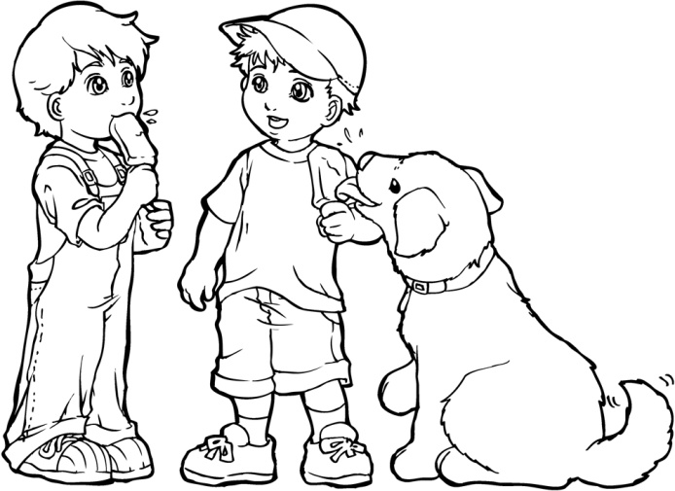

Here’s the beginning of a conversation you and your child can have. After you have read your parts, keep the conversation going by making up three more questions and answers.

*You: I have a cat. Your child: What’s his name?*

*You: Kitty. Your child: What kind of cat is he?*

*You: A Devon Rex. Your child: ______________________*

*You: _______________________ Your child: ____________________*

*You: _______________________ Your child: ____________________*

*Next, your child should tell you everything he learned about Kitty, beginning with “You have a cat named Kitty…”*

Now, switch the order. Your child starts the conversation by saying, “I have a friend.” When five questions have been asked and answered, it’s your turn to tell your child what you learned about his/her friend, beginning with “You have a friend…”.

* 1. **Being Assertive**

Learning Objective: To teach children how to assert their own rights without infringing on the rights of others.

Skill: Assertiveness

Explain your child that there is a difference between being assertive and being aggressive.

(Mother/Father) Tell him/her:

*You have many different rights, including the right to be safe, and the right to have the things you own left alone. If someone threatens you, teases you, or takes something that belongs to you, they are taking away your rights and being aggressive.*

*Being assertive means sticking up for your rights or the rights of others. It does not mean taking away the rights of others. For example, if a child grabbed your book and you reacted by pushing him, you would both be aggressive. If you clearly and firmly told him to return your book, you would be assertive.*

*It is important to be assertive, sticking up for yourself and also for other children, particularly if they are younger or smaller. It is not always easy, and it may mean speaking up when you are afraid. Even if you feel like you are tattling, you may need to get an adult to help you.*

Ask your child to share examples of assertiveness from his/her own behavior or from his/her observations.

Do the assertive and the assertor in turn with your child and role-play the situations described below. Make sure that children have a chance to be both Assertor and Aggressor.

Aggressor: You are a bully trying to get the other person’s snack.

Assertor: You try to stop the bully without being rude or angry.

Aggressor: You say something mean about the other child’s family.

Assertor: You respond calmly and firmly, saying how you feel without getting angry.

Aggressor: You call the other child "stupid," because he is having trouble in school.

Assertor: You say how name-calling makes you feel without getting into an argument.

Aggressor: You make faces to annoy the other child.

Assertor: You say something to stop this behavior, and if it continues, you ignore it.

Aggressor: You tease the other child about his/her haircut.

Assertor: You tell the teaser that you don’t like being teased in a calm, but firm voice.

Aggressor: You broke a toy, but you lie and say the other child did it.

Assertor: You tell the other child how you feel about the situation without getting angry.

Aggressor: You cut into line at the movies in front of the other child.

Assertor: You say that cutting in line is breaking the rules. Then you decide on the best solution to the problem without arguing or fighting.

**EVALUATION OF THE PRACTICE:**

We can use three simple indicators to evaluate if practices about prosocial skills have impacted on children. The development of pro-social skills can be viewed as a three-part process:

* First, in the recognition step, a child must be able to determine if someone needs help.
* Second, the child must decide whether to help or not to act.
* Third, a child must act by selecting and performing an appropriate behavior for that situation.

| **Examples of Skills learned to Solve Problem Behaviors** | |
| --- | --- |
| ***Problem Behaviors*** | ***Skills learned*** |
| Screaming when he/she cannot reach something he/she wants | Use please and thank you |
| Demanding — “give me” | Demanding — “give me” |
| Yelling — “that’s mine” | How to share |
| Hurting someone. Out of control yelling | How to deal with angry feelings. Say I am sorry. |
| Interrupting or insisting on doing it now | Accept no as an answer |

**COMMENTS FOR IMPLEMENTATION:**

Homework has been shown to have a positive effect on a student’s academic performance. Homework allows children the opportunity to use social skills as situations arise in natural, rather than in artificial, settings and is also an excellent way to involve parents in social skills instruction and to foster home-school collaboration.

Social skills homework is appropriate when it is a planned extension of classwork and is evaluated by teachers, students, and parents.

**OTHER USEFUL RESOURCES** (ex. links where you can find more information on the given topic):

<https://www.parentingscience.com/social-skills-activities.html>

<http://www.parenthelpline.org/Global-PDFs/Skill-Time-Booklet>

### SCHOOL FEAST

**AREA (OBJECTIVES):**

1. Planning of common work;
2. How to involve parents in a school life.

**THEORETICAL BACKGROUD** (if needed):

By preparing this holiday, parents will be actively involved in the school life of their children and will contribute to a better climate in school.

**DESCRIPTION:**

Рarents will prepare a school feast related to Easter. They will decorate the school salon and prepare treats for children. The decoration will include balloons, paper garlands, flowers, painted eggs.

**EVALUATION OF THE PRACTICE:**

With the preparation of this feast, parents will have the opportunity to work with children and their teachers. This will help to improve relationships between parents and students, parents and teachers, as well as between the parents themselves.

### LET ME TELL YOU ABOUT MY JOB…/VOCATIONAL CONSULTING

**AREA (OBJECTIVES):**

1. Encouraging parents to enter the classroom and feel the atmosphere;
2. Giving parents the opportunity to become inspirers;
3. Studying the environment;
4. Engaging the parents in school life ;
5. Benefiting from the parents’ knowledge, sharing it with the class group;
6. Planning of common work;
7. A plan of lesson with parents.

**THEORETICAL BACKGROUND:**

„We live in a dynamic world of constant change. Research shows that over 60% of children currently in primary school will work in occupations that do not yet exist. The professions come and go. The times when a linear career model was in force, in which a pharmacist graduate became a pharmacist and worked for one pharmacy for years, have long since gone away. Young people entering the education market and the labour market face enormous information chaos and data variability.

Choosing an educational and professional path becomes not a one-off event but a process that takes place throughout life.

It is important not only WHAT to choose but also HOW to choose. The fact that a child, for example, 12-14 years of age, dreams of a lawyer's career, does not mean that in 4-5 years the dream will still be valid. But certainly without the skill of good communication, identification of own beliefs, setting and achieving goals, and above all finding the answer to the question of who I am and where I am going on my way of life, it will be difficult to achieve real professional success.

Therefore, quoting P. Voelkel, "the key thing is to discover your own passions, talents, your own potential and start investing in this area". When does a person have a chance to feel satisfaction from what he/she does? When he/she works according to his/her strengths, when he/she believes in what he/she does, because it is in line with his/her values. Self-awareness, or knowledge about what I do at a given moment and what I do for it, what is important to me and more importantly - is crucial in the process of setting my educational and career path. Its good construction and knowledge of the labour market are necessary to achieve a professional goal. Even if in the future it will change and the unexpected circumstances of life will have an impact on it.

The omnipresent change and uncertainty are in opposition to traditionally understood counselling. Its goal was to design linear career paths and refer to the future of what is a fact now. Meanwhile, we can only assume today's standards will not directly affect the future of our pupils.

Modern counselling should have a procedural character, and the counsellor should act as a companion and expert on the understanding of the process. His/her task is to propose appropriate tools that will make it easier for a young person to constantly and independently search for their own way of life, and not to give schematic advice and ready answers, as is often in the case of traditional counselling.

The intention of the advisory process should be to strengthen and develop the pupils' potential. It is worth to support the development of social competences, the ability to think creatively and deal with difficult situations, as well as to independently search for information. And it should always be emphasized that a decision made once does not have to be a decision forever. Thus, contemporary education and career counselling is approaching in its assumptions and methods for coaching, especially career coaching and life coaching.”[10]

In primary school (grades I-III), as part of activities related to vocational counselling, classes should be conducted in order to:

* enabling the confrontation of tendencies, interests, talents, and specific professional situations,
* as comprehensive as possible to familiarize children with various types of professional areas and occupations,

shaping a particular motivation for professional development.[11]

**DESCRIPTION:**

Some parents who have interesting jobs will be invited to come and tell pupils about their occupations. The parents will tell the pupils what they actually do every day, what the challenges they meet are and how their jobs give them the chance to help people and/or make people’s lives better/easier/more exciting/more interesting. Parents will feel free to turn their presentation ideas into action for achieving impact on and impressing pupils.

Parents are going to present and speak about a subject related to their work area (job) or knowledge (stories and customs of where they live). The way their activity is going to be presented is of their own initiative (it can be a film, a Powerpoint presentation, bring some supporting material or just talking).

From these different types of knowledge, a content/topic within the subject of Study of Environment will be introduced.

**EVALUATION OF THE PRACTICE:**

At the end of the school year the pupils will be encouraged to write essays about MY DREAM JOB and read them to the class.

**COMMENTS FOR IMPLEMENTATION (if possible)**:

Usually parents are very willing to apply for this action. It is worth paying attention that each of the parents is involved on an equal level in the implementation of the activity - that everyone who wants can talk about his/her profession. For children it is also very important that their parents get involved in this action. It is a simple activity that strengthens the cooperation of parents with the school.

**OTHER USEFUL RESOURCES** (ex. links where you can find more information on the given topic):

*SONG*

*One day I’d like to find*

*the perfect job for me.*

*Mary says she wants to cook,*

*Susie wants to write a book.*

*Mathew wants to work in a shop…*

*Shop assistant – a nice job!*

*Chorus:*

*But I don’t really know*

*what I want to be.*

*One day I’d like to find*

*the perfect job for me.*

*But I don’t really know*

*what I want to be.*

*One day I’d like to find*

*the perfect job for me.*

* <http://www.interaktywnaedukacja.pl/?p=486> – website with materials in Polish.

### BEGINNING ANEW

**AREA (OBJECTIVES):**

Managing conflict situations in communication.

This practice will help us to develop a kind speech and a compassionate listening. Begin Anew is a practice of recognition and appreciation of the positive elements within our School or home environment.

**THEORETICAL BACKGROUD (if needed):**

Plum village Community, Thich Nhat Hanh.

**DESCRIPTION:**

To “Begin anew” helps us to look deeply and honestly at ourselves, our past actions, our speech and our thoughts, and can help us to create a fresh beginning within ourselves and in our relationships with others.

This practice helps us to clear our mind and solve pending issues or misunderstandings in our relationships. It is a very useful practice whenever a difficulty arises in our relations with others and one of us feels hurt or resentment. This practice can give us the opportunity to start again and understand better the other person.

This practice is *a four-part process* as used in a formal setting. Only one person speaks at a time and is not interrupted during his or her turn. This is very important to respect so that we gve the other person space and time to express himself/herself. The other person will practice a deep listening and will follow with full awareness their breath coming in and out. It is also recommended to take time and pauses and feel what we feel in each moment, so that we can embrace what is.

It is a practice to be done ***One by One*,** or in case needed, with a third person that both people trust and respect, for example in a school conflict etc.

1**. Flower watering** – we start the conversation sharing our appreciation for the other person. We can mention concrete actions that the other person said or did that we value or appreciate in them. This is an opportunity to shine light on the other’s strengths and to encourage the growth of his or her positive qualities. In this way, we make easier for the other person to open up to us and be receptive for the conversation.

2. **Sharing regrets** – We can continue mentioning any unskillfulness in our actions, in our speech or in our thoughts that we may have had, and had not yet an opportunity to apologize for it.

3. **Expressing a hurt** – We can share how we have felt hurt by the interaction with the other person, maybe because something he/she did or said. By Saying; “I felt this way when you said or did this…” never “you did this or that…” In this way we can learn to take responsibility of what is ours and share it with others from this place.

4. **Sharing a long-term difficulty & asking for support**- we all go through difficulties and pain in many moments of our lives. Sometimes a situation in the present moment can arise a pain from our past back to the surface. By sharing how we felt we can let the people around us understand and get to know us better in offer to support us in what we need.

This practice will help us to develop a kind way of speech and a compassionate listening. Begin Anew is a practice of recognition and appreciation of the positive elements within our School or home environment. 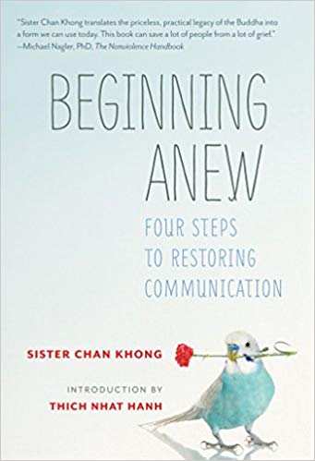

Recognizing others positive traits will allows us to see our own good qualities as well.

Along with these good traits, we each have areas of weakness, such as talking out of our anger or being caught in our misperceptions. When we practice “flower watering” we support the development of good qualities in each other and at the same time we help to weaken the difficulties in the other person. As in a garden, when we “water the flowers” of loving kindness and compassion in each other, we also take energy away from the weeds of anger, jealousy and misperception.

**EVALUATION OF THE PRACTICE:**

*You can ask yourself these questions;*

* Have you been able to express your feelings? And the NEEDS hidden behind?
* Do you feel the other persona has understood your position?
* Did you understand the feelings and position of the other person?
* Could you find a meeting point in the solution of the conflict that has made the situation better?

**COMMENTS FOR IMPLEMENTATION (if possible):**

* Choose a good moment for both persons to do this practice. Maybe is good to have a moment every week to do this practice and clean any situations during the week.
* Only one person speaks at a time and is not interrupted during his or her turn.
* The other person will practice a deep listening and will follow with full awareness their breath coming in and out. It is also recommended to take time and pauses and feel what we feel in each moment, so that we can embrace what is.
* It is a practice to be done ***One by One*,** or in case needed, with a third person that both people trust and respect, for example in a school conflict etc.

**OTHER USEFUL RESOURCES (e.x links where you can find more information on the given topic):**

[**https://plumvillage.org/**](https://plumvillage.org/)

### MINDFULNESS IN CONFLICTS

**AREA (OBJECTIVES):**

|  |  |
| --- | --- |
| 1. Management of conflicts. 2. Emotional regulation. 3. Favors self-control.   **THEORETICAL BACKGROUD (if needed):**  Mindfulness in the resolution of conflicts. |  |

**DESCRIPTION:**

Mindfulness tips for reducing reactivity. We can use mindful practices to create space between an outburst of anger or another strong emotion so that we may have more possibility to choose in a conscious way. In some situations, this could be just walking away or taking a pause, or a deep breath before we speak. As we learn to practice these skills ourselves, we can later on teach our kids on how to respond mindfully.

The steps that will help us become mindful in a conflict situation will be:

1. **Always pause** — When a conflict arises, take a pause and a deep breath. Take a moment to breathe slowly and notice the air coming into and going out of your lungs and belly. Focusing on your breath and body so that you ground yourself in the present moment. Come out of the mind as much as you can.
2. **Allow yourself to feel what you’re feeling**— Pay attention to your thoughts and emotions, knowing that you are not them. Is your mind racing with angry thoughts? Do you feel hurt or embarrassed? Just become aware of thoughts and emotions that arise in you and accept them. They will settle if you don’t react to them, and just let them be and embrace them with full acceptance.
3. **Do a brief**[**body scan**](https://www.mindful.org/beginners-body-scan-meditation/)— Notice the physical sensations that arise with your thoughts and emotions. Are you clenching your jaw? Are you tightening your fists, ready to hit something? Are your leg muscles twitching, urging you to flee? Notice any muscle tension from your toes to the top of your head.
4. **Settle into your breath** — As you breathe, you will notice a pause at the end of each out breath before you breathe in again. During this pause, relax, and soften your muscles. Keep doing this for a few minutes, relaxing deeper and deeper into each pause.
5. **Acknowledge that you have space to choose** — Accept that you are upset and don’t try to change it. You could even say aloud, “I am upset.” Choose to be patient with yourself. If, however, your emotions feel too strong to investigate, acknowledge your difficulty and move away from the troubling situation. You can choose to return to the issue when you feel calmer, and choose a quiet space to get in contact with how you are feeling and the thoughts that are appearing on you.
6. **Challenge your assumptions** — Be open-minded to the views of others involved in the conflict. Don’t assume you know where people’s ideas come from or how other people are feeling. Challenge yourself to ask open-ended questions so that you can truly understand their perspective, and widen your view of life. Remember you are not your beliefs, and that is better to be happy then to be right.
7. **Avoid negative speech** — Name-calling is never helpful. Instead, explain your point of view clearly and acknowledge the viewpoints of others.
8. **Suggest a resolution** — Stick to the point of the conflict and suggest one or more ways to resolve it. Calmly discuss the pros and cons of each suggestion.
9. **Move forward** — Agree to try a resolution without resentment. And when you move forward with a suggestion, give it your full effort.
10. **Forgive**—Holding onto anger and resentment only hurts us and burdens relationships. Forgive yourself and others for being different and having an argument, and accept the idea that by learning to resolve conflict, we grow as people.

By practicing these 10 steps regularly, you can build a sense of confidence, well-being, and acceptance of challenging situations. These skills will serve you when you feel angry or divided as well as model resilient and positive examples of conflict resolution for our kids.

Write the steps in a paper and follow them whenever you find yourself in a conflict situation. Respect what you are feeling in each moment, and you can ask yourself “**what do you need to learn from this situation?”** to help you dissolve the conflict.

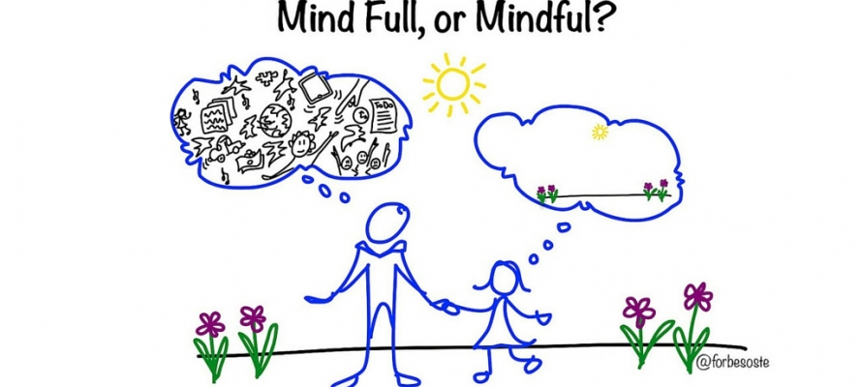

**EVALUATION OF THE PRACTICE:**

After putting it into practice we can see changes in the management of the conflict. Specially in the changes from being reactive, to becoming active, with more possibilities to choose.

**OTHER USEFUL RESOURCES (e.x links where you can find more information on the given topic):**

[Fleet Maull’s](https://fleetmaull.com/) Prison Mindfulness Institute’s Path of Freedom course

[Gina Biegel’s](https://www.stressedteens.com/about-gina-biegel/) Stressed Teens program.

### OFF-LINE FACEBOOK

**AREA (OBJECTIVES):**

1. Enhance an elevated comprehension of parental involvement and engagement.
2. Have parents get to know each other.
3. Break the ice among parents of a class.

**DESCRIPTION:**

Parents will map the connections between them on a whiteboard. Parents create their “avatars”, then draw lines to show how they know other parents. This can work great as an ice-breaker at the first teacher-parent conference.

**Duration:** 30 minutes

1. Parents are given markers, index cards, and tape. If possible, use markers of different colors.

2. Parent are requested to draw their "avatar" on the index card - their "profile picture" on this social network, so to say. They their names and the names of their children to each card as well.

3. Each avatar card is stuck on a large whiteboard. They make sure to leave plenty of room between each card.

4. Each parents is then aseked to draw lines to avatar cards of people they already know in the room. Also, they must specify how they know each other ("had the same workplace", "lunch buddies", "went to the same college").

**EVALUATION OF THE PRACTICE:**

Besides self-assessment two colleagues ought to be invited to this activity. They monitor and observe the activity and after the session a three-person discussion follows. The teacher and the two colleagues share all the positive and negative comments on the activity itself. Based on this think-aloud protocol, the teacher can adjust the steps the must be taken to improve the process of the session.

### PARENTS’ MEMORY GAME

**AREA (OBJECTIVES):**

1. To get parents to develop better cooperational skills with each other.
2. To enhance parents’ memory skills and to enhance parents’ group cohesion.

**DESCRIPTION:**

This is physical activity that establishes and parents’ shared memories. Thus, it must be implementedduring the academic year when parents will have gotten to know each other. Parents sketch their shared memories with each other and place them on a wall. The wall remains up during the session, working as a focal point of the parents’ shared experience of being in a team.

Steps:

1. Each parent is given sheets of paper, markers, and tape.

2. Each partent must survey the room and has 15 minutes to write down positive memories of shared experiences and moments while working together.

3. Once parents have a few memories listed, then they are requested to draw a few of these memories on fresh sheets of papers. The drawings can be abstract versions of the "memory scene". They can involve parents who've shared the memory to make this drawing. They are given 20 minutes to do this.

4. Once the time is up, parents are asked to tape drawings to the wall.

5. After taping the memories, each parent takes turns to describe the given memory.

**EVALUATION OF THE PRACTICE:**

Besides self-assessment two colleagues ought to be invited to this activity. They monitor and observe the activity and after the session a three-person discussion follows. The teacher and the two colleagues share all the positive and negative comments on the activity itself. Based on this think-aloud protocol, the teacher can adjust the steps the must be taken to improve the process of the session.

### LIKE SOCRATES: EDUCATING TO CRITICAL THINKING

**AREA (OBJECTIVES):**

INDEPENDENT AND CRITICAL THINKING

* Helping parents to encourage critical thinking in their children and to support them in acting free thinking and choosing.
* Giving parents strategies and practical instruments to educate their children to critical thinking.

**THEORETICAL BACKGROUND:**

Critical thinking, by its own definition, covers many aspects of a person’s life: it is knowledge, it is appliance, but above all, it is an attitude; it influences people’s independence and so it has a great impact on whole society. It creates connections with all other forms of thought and acts as a transversal skill, which allows the continuous and fluid passage from a thinking form to another.

To develop comprehensive and balanced individuals is appropriate to increase the education of critical thinking in the contexts of formal and non-formal education, so that training can start early and avoid some of the typical distortions of interpretation, to which we are naturally led.

Critical thinking is a basic trait for an education that is active, democratic, focused on effective needs of pupils and of the whole society.

In educating to critical thinking, isolated knowledge lose its value, because it is end in itself and unstable; what is really important is research and development of critical capacities.

Thinking critically means being able to assess situations, veracity of information and completeness of conclusions. It is not only the ability of logical reasoning; it is a personal attitude to openness about researching and asking.

A good level of critical thinking is not only necessary for the success of a course of study or for a personal psychological growth: its consequences affect the whole society, because they influence abilities of emancipation, dialectic, deep thought and so independence and freedom.

As Halpern says, critical thinking is connected to the capacity of reaching goals and asserting values and opinions and consequently of maintaining well-being and happiness.

Educating to critical thinking means giving children and youths a permanent “mind-suit”, which (unlike isolated knowledge that can be forgotten) is durable, lasts in time and influences the way of thinking and facing life.

It’s essential to continuously encourage children and youths (both in school and out of school) to use abilities of critical thinking, in order to make them able to see things from others’ point of views, to have an open mentality and to wonder “why?”.

Critical thinking is indispensable to raise free, independent, conscious and complete people, but it cannot be developed by an individual way but only by communication and exchange. It can happen only with the precondition and the purpose of collaborating, listening and support the development and the expression of other people’s thoughts and opinions.

Educating critical thinking is based on the variety of experiences that you can offer and on the dialogue, the collaboration, which you create during this process.

Therefore, collaboration with parents is essential in acquisition of transversal competences as critical thinking: in this way these abilities could be implemented by children and youth not only at school, but also and especially out of school, becoming an expertise they could bring with them all along their growth, until they will be adult.

Parent can be involved in different way, by training/informative meetings with teachers or observation sessions in classroom; but their role could be further enhanced by a direct action with children, in relation and coherence with teachers’ activities.

**DESCRIPTION:**

In common life routine, parents can act the following behaviours with their children:

* Observing and achieving results and conclusions

When children start to make precise observations on objects or information, so they can draw conclusions or explain judgments on that observations.

When a child ask parents “Why?”, parents have to reply saying “Why, according to you?”, in order to encourage him to draw his/her own conclusions.

This is the basics of scientific observation abilities, which will be useful and necessary in all children’s lives.

* Telling a story without conclusion

Telling a story without conclusion and asking children to complete it is an effective way to develop critical thinking competences.

Children have to take story’s information and complete it with creativity, drawing their own conclusion.

Parents can do that telling a story and asking to the child “What do you think will happen next?”.

* Implement the Socratic Method

Socrates is famous for his training to critical thinking by constant interrogation.

Children are naturally talented to ask questions, so parents can overturn the situation answering them with other questions.

On a specific topic, parents can take a position that is opposite of their child’s one and asking him relevant questions, so he is encouraged to affirm and uphold his opinions.

### ANIMALS’ EMOTIONS GAME

**AREA (OBJECTIVES):**

INDEPENDENT AND CRITICAL THINKING

* Helping parents to teach kids about emotion and to support them in recognising and expressing their emotions.
* Giving parents strategies and practical instruments to educate their children to emotional intelligence.

**THEORETICAL BACKGROUND:**

What is emotional intelligence? Many definitions exist out there. We can summarize it as follow: emotional intelligence is our ability to identify our feelings, to understand the reasons we feel them and the effect they have on others or us. It is also our ability to empathize with another and feel genuine compassion for them.

Emotional intelligence covers five main areas: self-awareness, emotional control, self-motivation, empathy and relationship skills. It is important for good communication with others and is therefore a gateway to better learning, friendships, academic success and employment.

The term emotional intelligence was popularised in the mid-90s by Daniel Goleman’s book, Emotional Intelligence: Why It Can Matter More Than IQ.

An iconic study tracked high-IQ students from childhood to late adulthood and found that those who achieved notable adult career success showed greater “will power, perseverance and desire to excel”. Meanwhile, evidence from the seminal marshmallow test – which gave children the option to have more treats if they could wait before eating them – suggested delayed gratification and self-control are important, with these characteristics being linked to better school grades, earnings and job satisfaction.

This is emotional intelligence as defined by Daniel Goleman:

* Self-Awareness – knowing what we are feeling, why we are feeling it, making it a basis for good intuition and decision making.
* Self-Management – handling your distressing emotions in effective way so they don’t cripple you, yet attuning to them and learning what you must out of them. Being able to handle stressful situations effectively. Aligning our actions with our passions.
* Internal Motivation – ability to understand and focus on what is important to reach one’s goals and dreams.
* Empathy – knowing what someone else is feeling. Being able to put yourself into another person’s shoes, to understand them and provide support.
* Social Skills – being able to foster and maintain rich relationships.

Studies have shown that children with higher emotional intelligence perform better in school, deal better with stress and stay away from depression.

By helping kids develop their emotional intelligence, your help them enrich their personality, improve the quality of their relationships, increase their ability to persevere, have a positive outlook on life, as well as be an overall successful individual. You set them up early to be champions for themselves from the inside out, bringing out the best version of themselves to the world. You help them become a master of their own thoughts and feelings, ultimately becoming the master creator of their own life.

When you teach kids emotional intelligence, how to recognize their feelings, understand where they come from and learn how to deal with them, you teach them the most essential skills for their success in life. Research has shown that emotional intelligence or EQ “predicts over 54% of the variation in success (relationships, effectiveness, health, quality of life).” Additional data concludes that “young people with high EQ earn higher grades, stay in school, and make healthier choices.”

Young kids do not always know which emotions they are feeling and rarely do they know how to respond to them.

Kids will not learn to differentiate emotions unless we teach them how. They may know they are feeling “something,” but they do not necessarily know what that “something” is. This largely explains why understanding kids’ emotions can help reduce what we normally perceive as misbehaviour.

Treating kids’ emotions as valid and regularly speaking about feelings – how did you feel, how do you think he feels, why do you think she is so sad? – goes a long way in teaching them to manage their emotions.

In this teaching activity parents perform, of course, a fundamental role.

**DESCRIPTION:**

In common life routine, parents can play with their children the Animals’ Emotions Game.

In this game, parents could use the natural attraction of children for animals to encourage identification and expression of emotions.

The game is played by rolling two dices and acting out whatever you roll.

Parents will be equipped with two dice:

* the first dice has on each side the name and the drawing of one of 6 emotions
* the second dice has on each side the name and the image of a different animal.

|  |
| --- |
| **Four basic emotions**  MAD SAD  HAPPY SCARED  **More option**  HURT FRUSTRATED JOYFUL  SLEEPY ASHAMED SILLY  SHY LONELY |

The dices could be provided by the school or could be built by parents and children, following instructions and using models provided by the school.

The game:

* One player rolls the two dices.
* Referring to the resulting couple of animal and emotion, the player imitates the animal living that specific emotion.
* The turn passes to another player and so on.

It’s possible to choose different variations:

* you can write/draw other emotions on the dice, making children choose the ones they prefer
* instead of animals you can use 6 family persons or 6 places children frequent or any other things that can inspire children.

This game can also be taken a step further, depending on children’s readiness to explore emotions deeper. For instance, when the child acts out a mad animal, parents can talk about the best ways to handle anger. They can put it in terms of how an animal might react because children tend to relate well to animals.

### PARENTS’ SCHOOL / SCHOOL FOR PARENTS

**AREA (OBJECTIVES):**

1. Engage the parents in school life;
2. Attract parents to school;
3. Involve parents in the education of their children;
4. Promote the value of education among parents;
5. Clarify doubts/questions/Concerns raised by parents;
6. Enhance active parents in the learning process of their children;
7. Help parents to study with children and not studying for them.

**METHODOLOGY / TECHNIQUES:**

Open conversation/roundtable/dialogue/share of practices.

**THEORETICAL CONTEXT (if applicable):**

* Lack of parental interest in school;
* Lack of time of parents to come to school;
* Little involvement of parents in school education;
* Careless parents in the raising of their children, leaving this responsibility to school.

**DESCRIPTION:**

Monthly sessions with the aim of jointly reflecting on relevant themes; topics covered:

* Hyperactivity;
* Anxiety;
* Active Parenting Strategies;
* Study methods and strategies;
* Challenges of social / online networks;
* Professional orientation/guidance;
* Etc.

**EVALUATION OF THE PRACTICE:**

Direct observation.

The sessions are evaluated qualitatively by the participants and a questionnaire was prepared to be completed at the end of each session.

### ROUND TABLE WITH ... PARENTS AND GUARDIANS ON POSITIVE PARENTING

**AREA (OBJECTIVES):**

1. Encourage cooperation between the various educational agents;
2. Encourage group reflection and self-reflection on attitudes and behaviours of children / students and parents / guardians;
3. Contribute to improving the school - family relationship;
4. Collaborate in the convergence of basic education principles to Basic Education;
5. Know and train strategies to deal with children's inappropriate behaviour;
6. Realize the importance of educating positively and knowing the strategies so that this is possible;
7. Enable peer discussion.

**TARGET GROUP:**

Parents and caregivers of students attending Primary school.

**TIMELINE IMPLEMENTATION:**

1st term – November (for parents /guardians of the 1st and 2nd grades)

2nd term – April (for parents / guardians of the 3rd and 4th grades)

**METHODOLOGY / TECHNIQUES:**

Work session conducted by the Psychologist of the Group, composed of two parts:

I Part – Presentation of the theme/topic;

II Part – Discussion and sharing of experiences/practices **.**

Working mode: Collective work / Team work

**RESOURCES:**

* Auditorium (for holding the session);
* Computer;
* Videoprojector;
* Power Point Presentation.

**DESCRIPTION:**

For each of the sessions, we send an invitation to all the parents / guardians of the pupils who attend the respective grades/school years in the School. We use the schoolbook as a communication vehicle to invite parents.

Organization of each session according to the target audience and the theme to be addressed: "Positive parenting".

I Part:

* Presentation of participants
* Explanation of the topic through a Power Point presentation (under the responsibility of the psychologist)

Part II:

* Dialogue with parents and debate on the theme;
* Individual response/care/support to the parents/caregivers who have specific situations and who need personalized treatment.

**EVALUATION OF THE PRACTICE:**

Direct observation (participation and interest of parents / guardians);

Number of participants.

**OTHER IMPORTANTE RESOURCES (links, etc.):**

*The enclosed Power Point – also as additional document to the ToolKit – Annex no. 3*

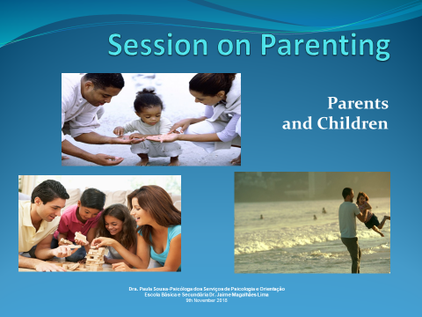 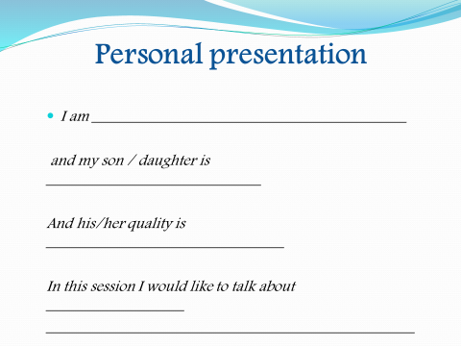

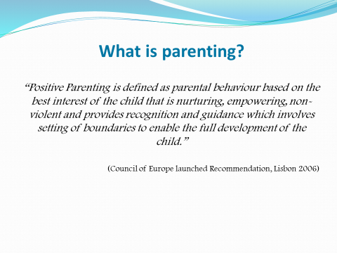 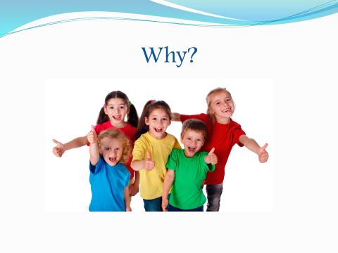

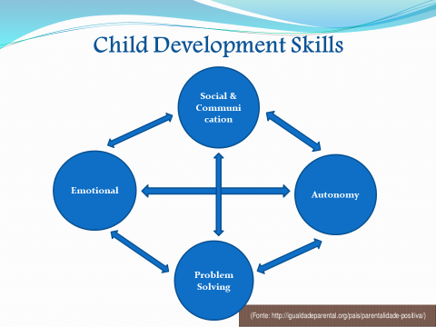 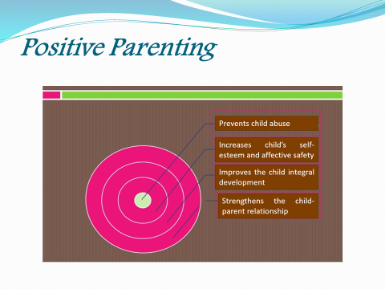

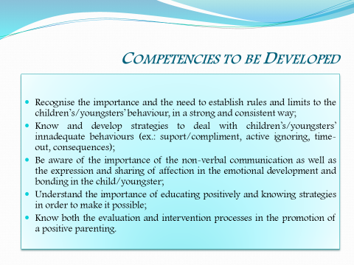 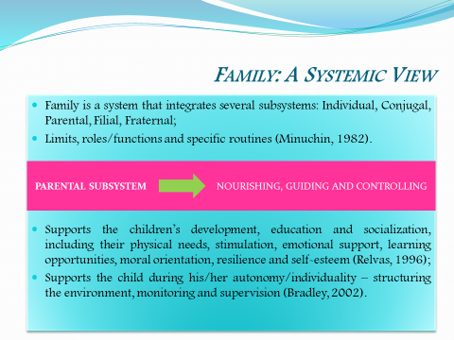

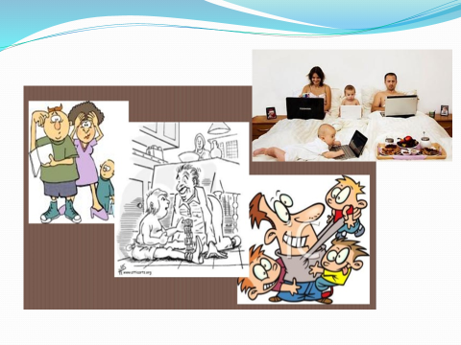 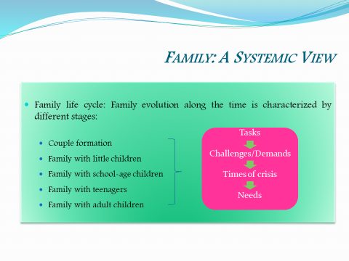

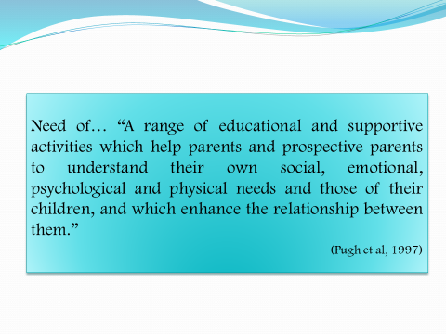 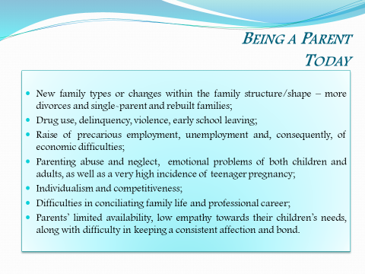

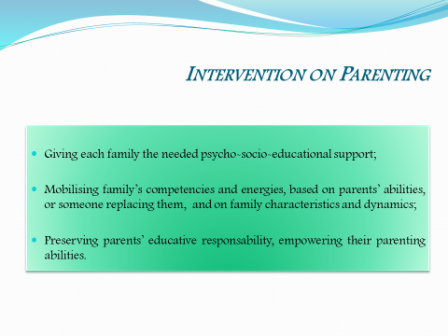 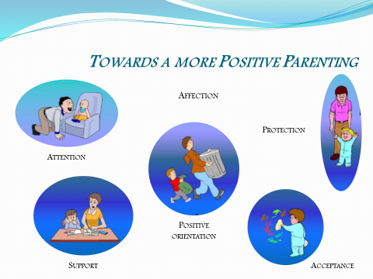

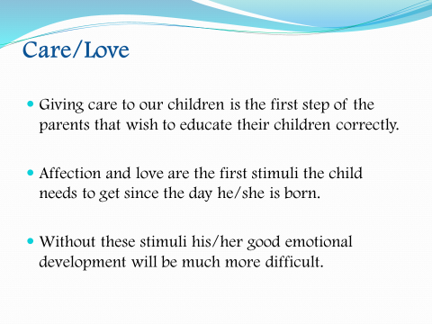 

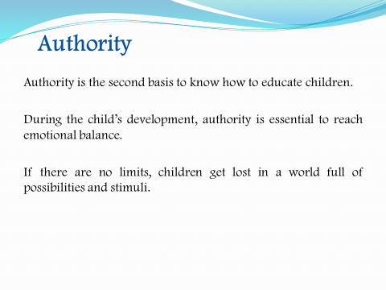 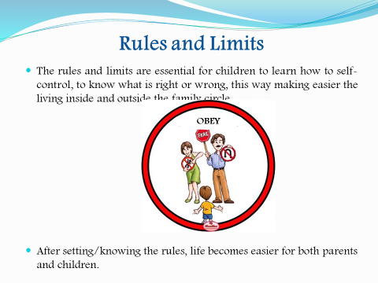

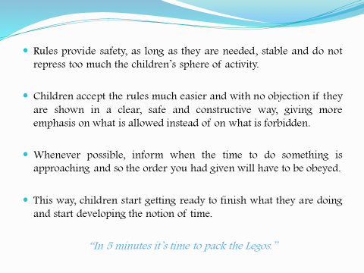 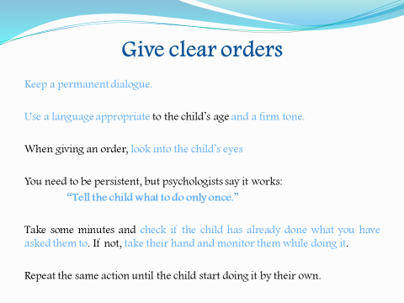

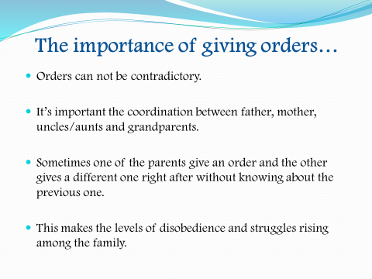 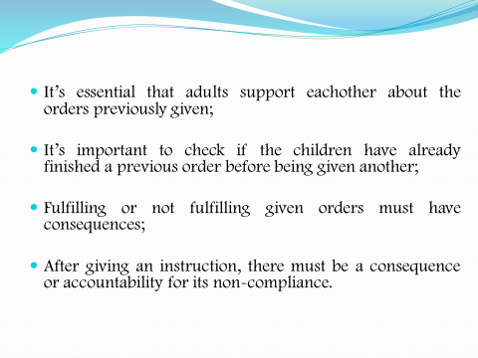

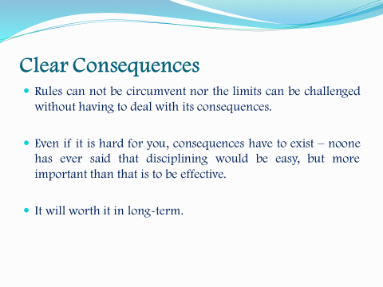 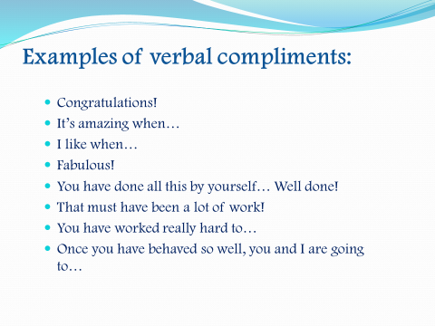

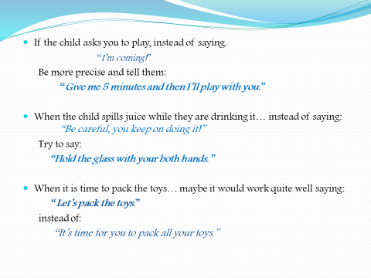 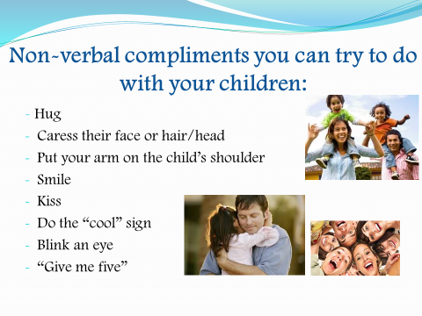

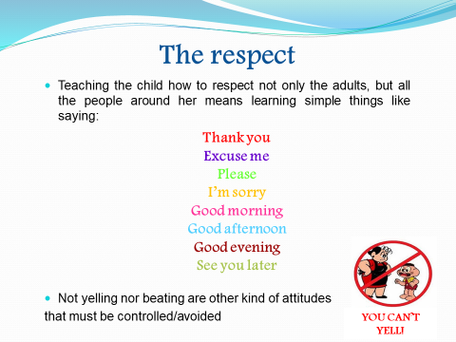 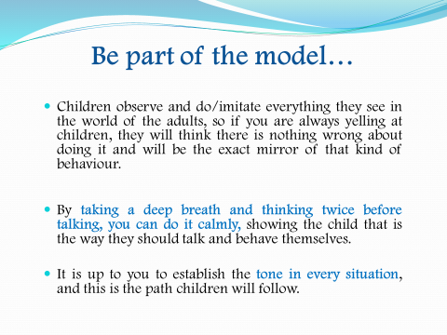

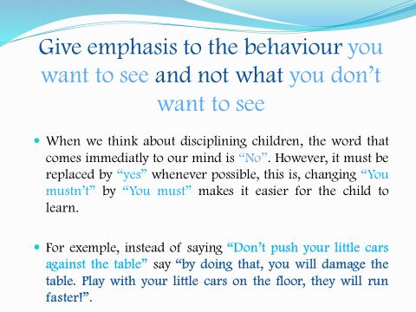 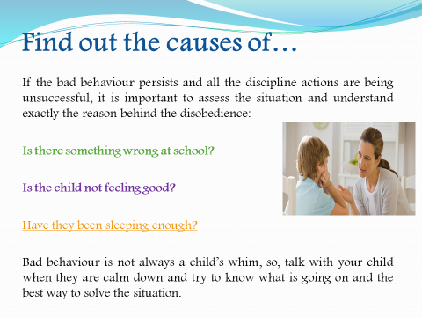

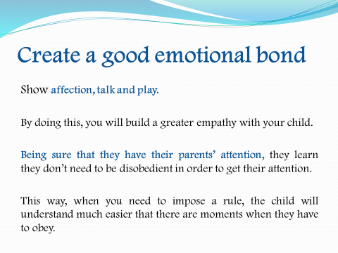 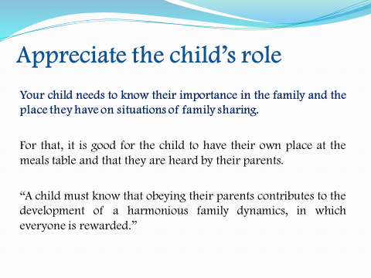

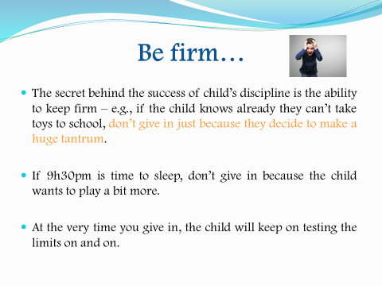 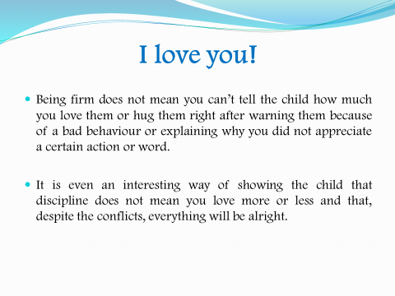

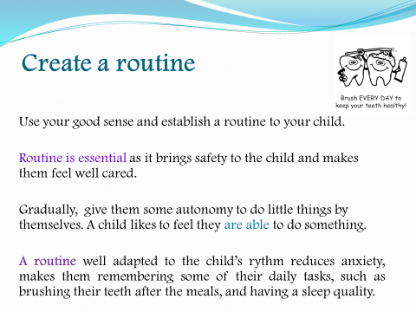 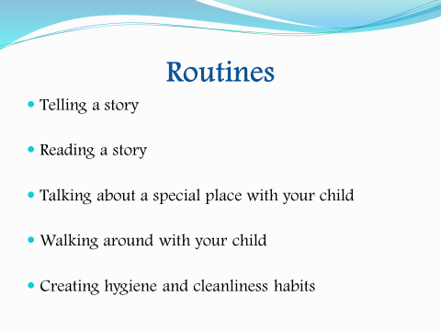

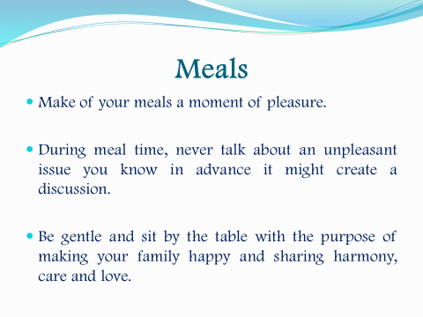 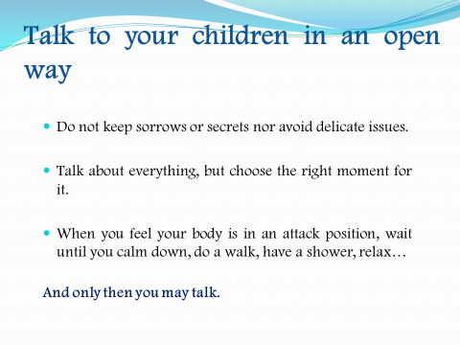

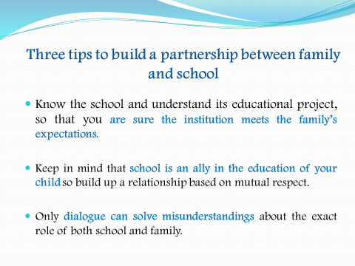 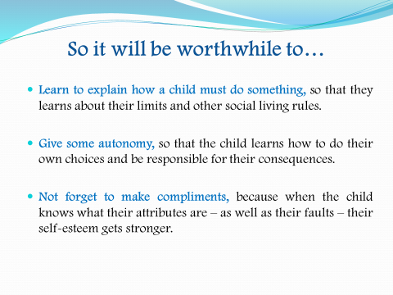

### BIBLIOGRAPHY

1. Anna Konkel-Zając, „Jak zorganizować doradztwo zawodowe w szkole”, https://indywidualni.pl/edustrefa/jak-zorganizowac-doradztwo-zawodowe-w-szkole
2. <http://blizejterapii.blogspot.com/2014/12/balony-zosci-cwiczenie-w-pracy-ze-zoscia.html>
3. <https://emocje-cialo-umysl.pl/7-pomyslow-jak-cwiczyc-mindfulness-z-dziecmi/>
4. <http://pracowniakapeluszy.wordpress.com/2012/10/19/bajka-o-cieplym-i-puchatym/>
5. <http://www.interaktywnaedukacja.pl/?p=486>
6. <http://www.zosia.piasta.pl/bajka.htm>
7. National Coalition for Parent Involvement in education. 2006. *Research Review and Resources.* Retrieved September 16, 2011. Henderson, A.T., and K.L. Mapp. 2002. *A New Wave of Evidence: The Impact of School, Family, and Community Connections on Student Achievement.* Henderson, A.T., and Nancy Berla. 1995. *A New Generation of Evidence: The Family Is Critical to Student Achievement.* Washington, DC: Center for Law and Education, 14–16
8. *Poradnik Wychowawcy*, February 2001
9. Toolkit for Family Involvement in Education, Oregon Department of Education, 2006
10. Toolkit for Parental Participation, National Guidance & Local Implementation, December 2015, Tusla - Child and Family Agency, 2015

1. Based on the article from the site http://blizejterapii.blogspot.com/2014/12/balony-zosci-cwiczenie-w-pracy-ze-zoscia.html
2. Based on the article from the website https://emocje-cialo-umysl.pl/7-pomyslow-jak-cwiczyc-mindfulness-z-dziecmi/
3. The story quoted after: *Poradnik Wychowawcy*, February 2001.
4. Content of the fairy tale after: http://pracowniakapeluszy.wordpress.com/2012/10/19/bajka-o-cieplym-i-puchatym/
5. The story after: http://www.zosia.piasta.pl/bajka.htm
6. There are eight basic emotions according Robert Plutchik's theory.
7. National Coalition for Parent Involvement in education. 2006. *Research Review and Resources.* Retrieved September 16, 2011. Henderson, A.T., and K.L. Mapp. 2002. *A New Wave of Evidence: The Impact of School, Family, and Community Connections on Student Achievement.* Henderson, A.T., and Nancy Berla. 1995. *A New Generation of Evidence: The Family Is Critical to Student Achievement.* Washington, DC: Center for Law and Education, 14–16

   .
8. A Toolkit for Family Involvement in Education, Oregon Department of Education, 2006
9. Toolkit for Parental Participation, National Guidance & Local Implementation, December 2015, Tusla - Child and Family Agency, 2015
10. Anna Konkel-Zając, „Jak zorganizować doradztwo zawodowe w szkole”, https://indywidualni.pl/edustrefa/jak-zorganizowac-doradztwo-zawodowe-w-szkole
11. After: http://www.interaktywnaedukacja.pl/?p=486